# 600 MHz, 30mm (0.06λ)

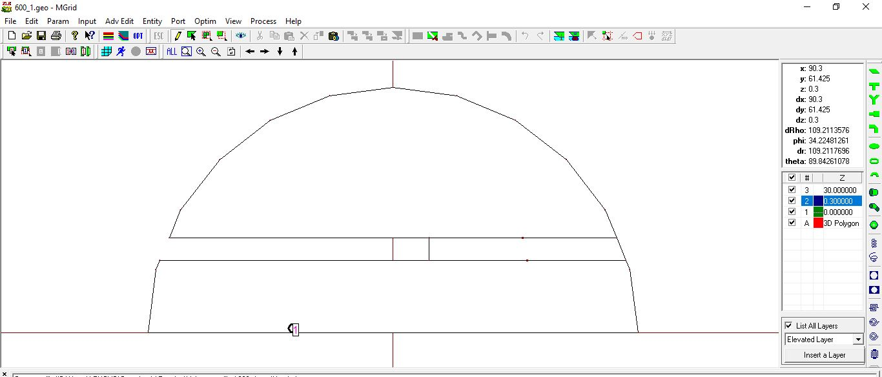

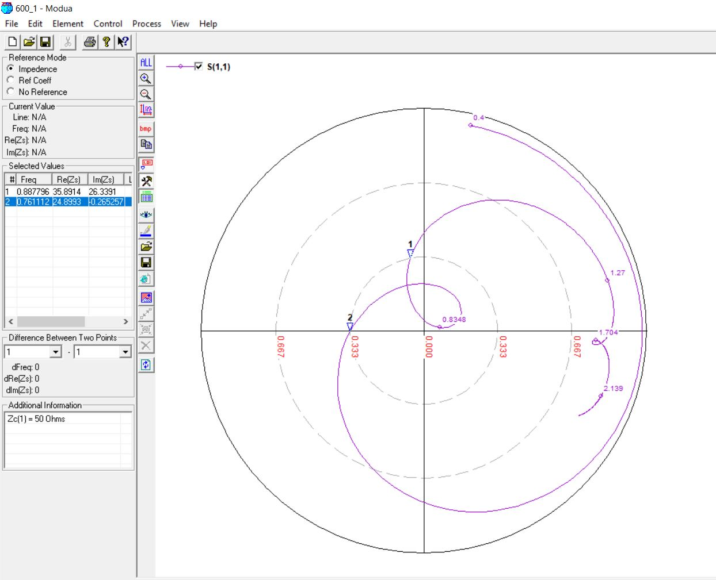

600 MHz, 30mm (0.07λ)





600 MHz, 30mm (0.08 λ)

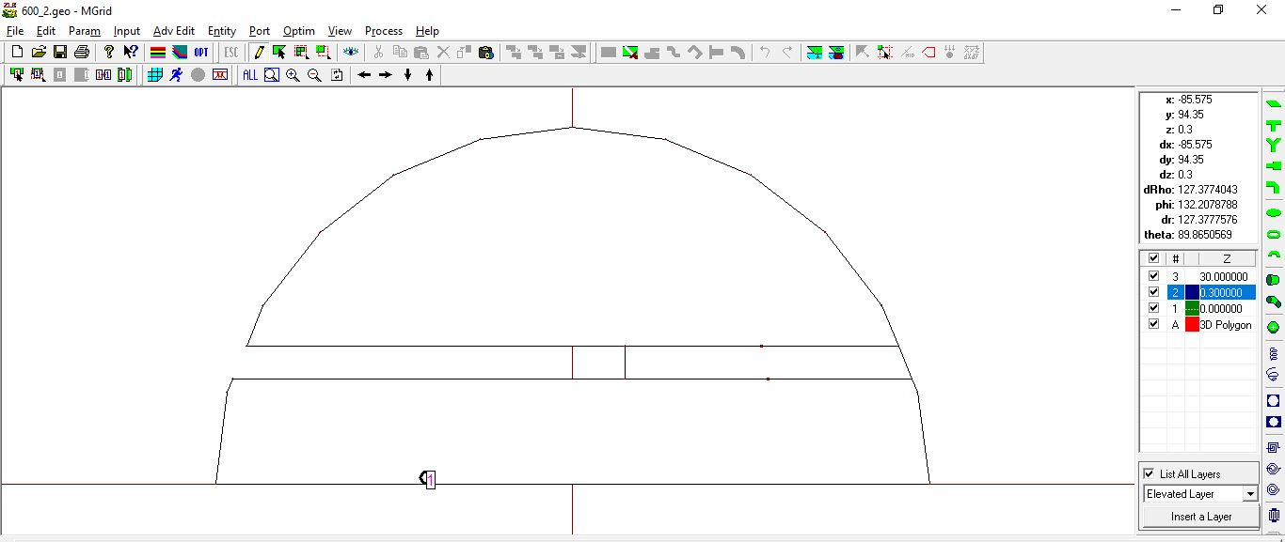

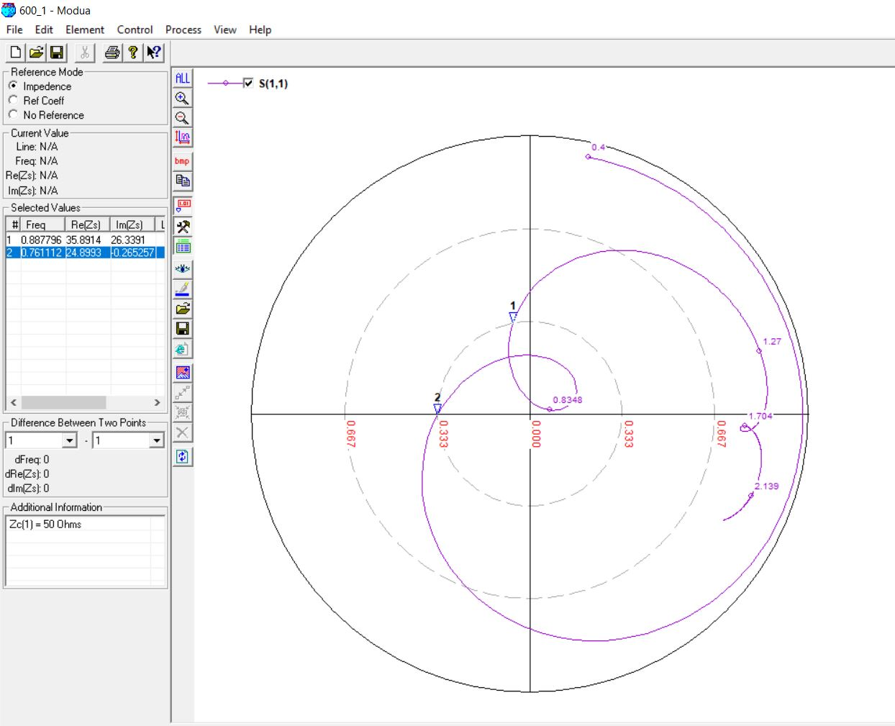

700 MHz, 30mm (0.06 λ)

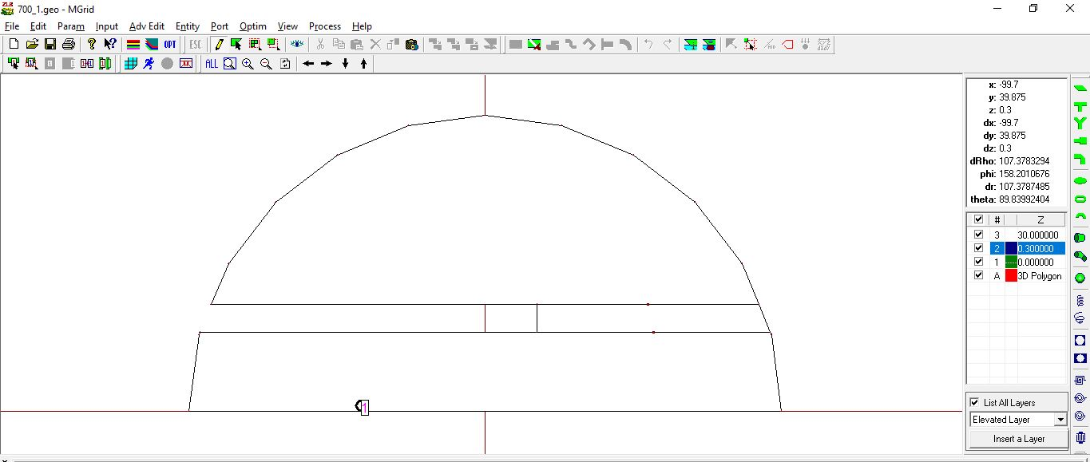

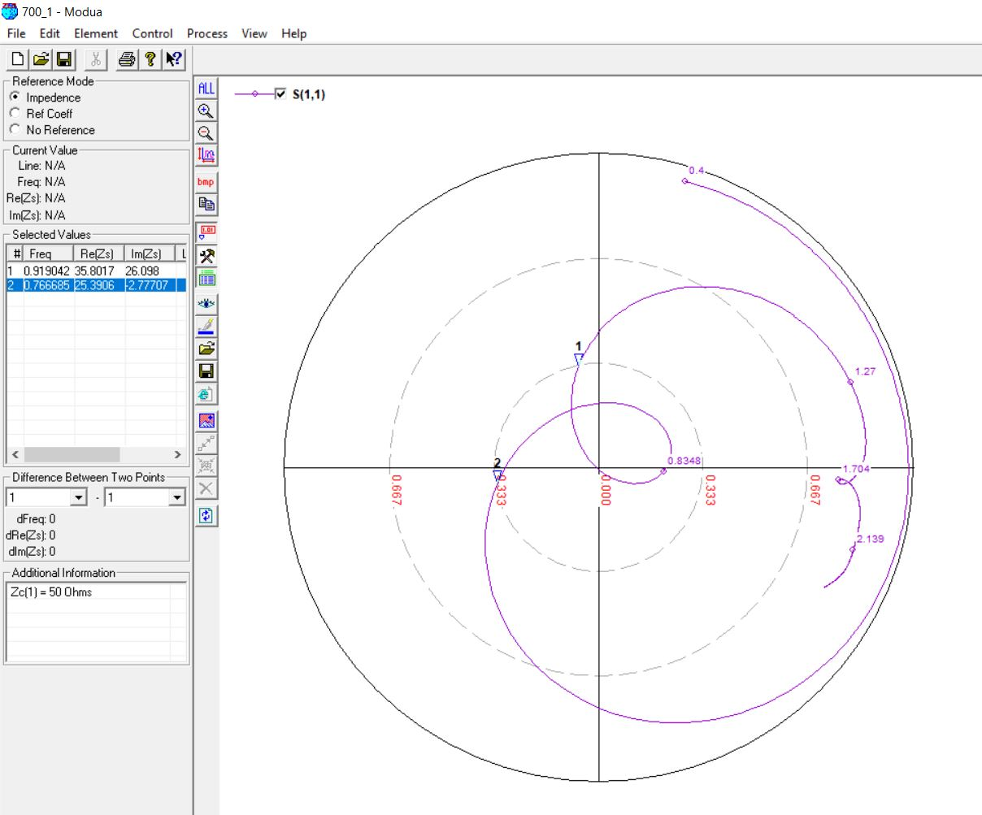

700 MHz, 30mm (0.07 λ)





700 MHz, 30mm (0.08 λ)

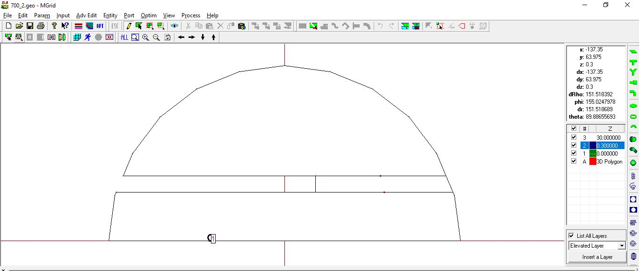

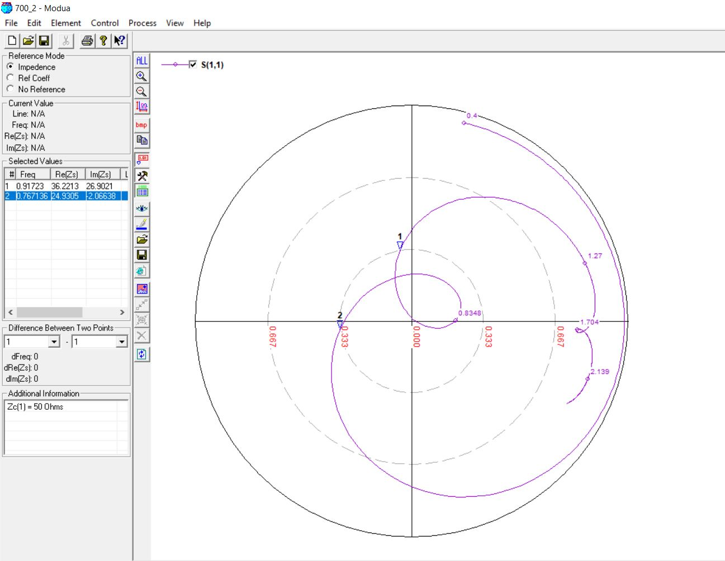

900 MHz, 20mm (0.06 λ)

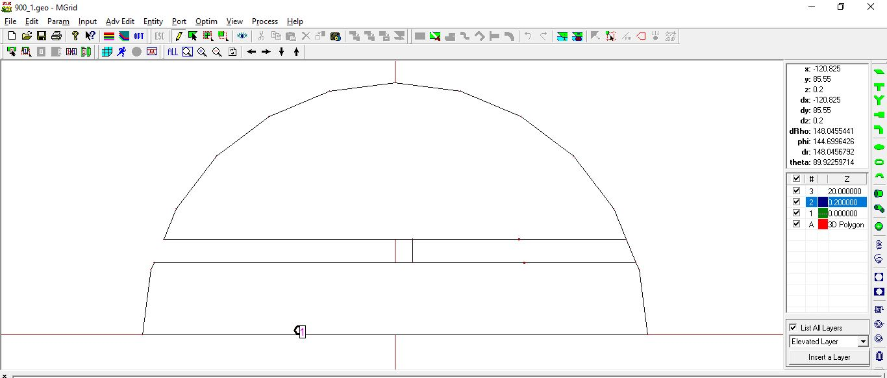

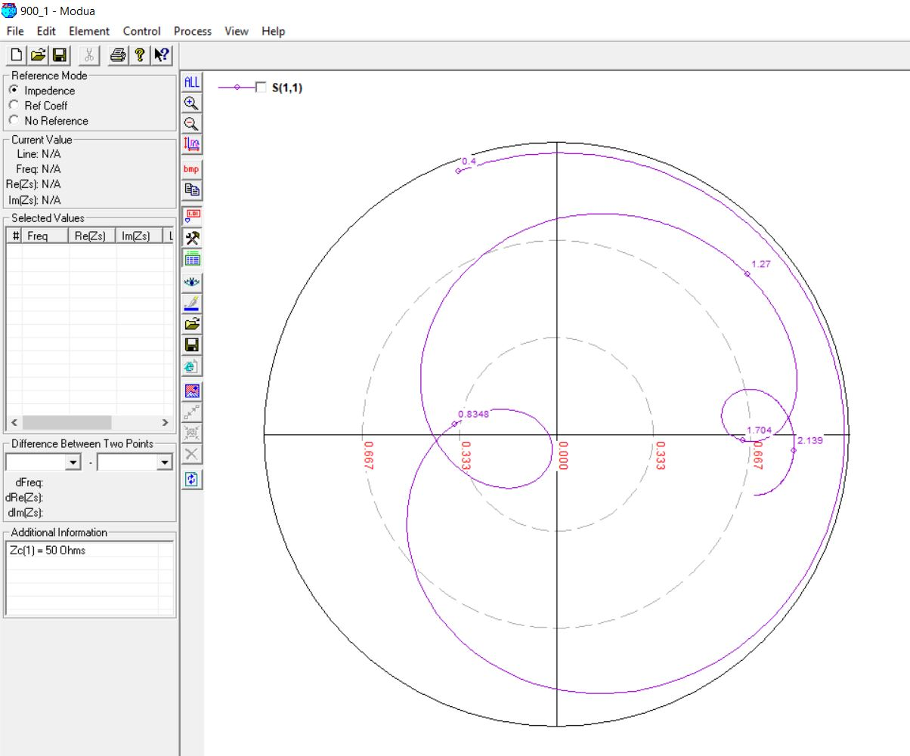

900 MHz, 22mm (0.07 λ)

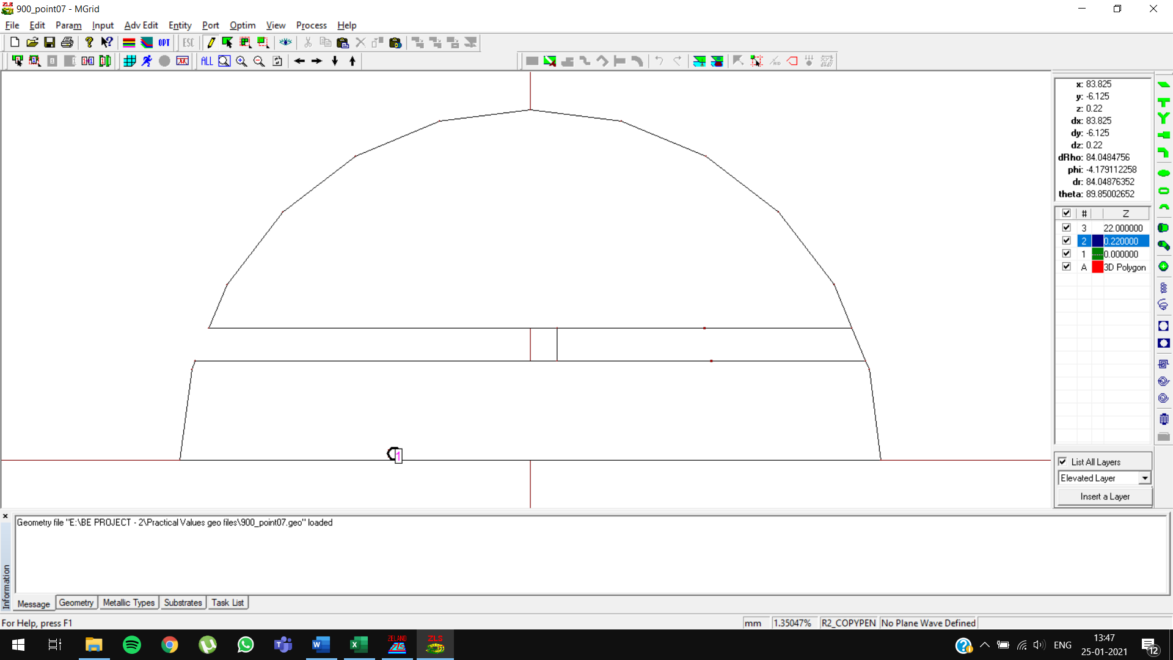

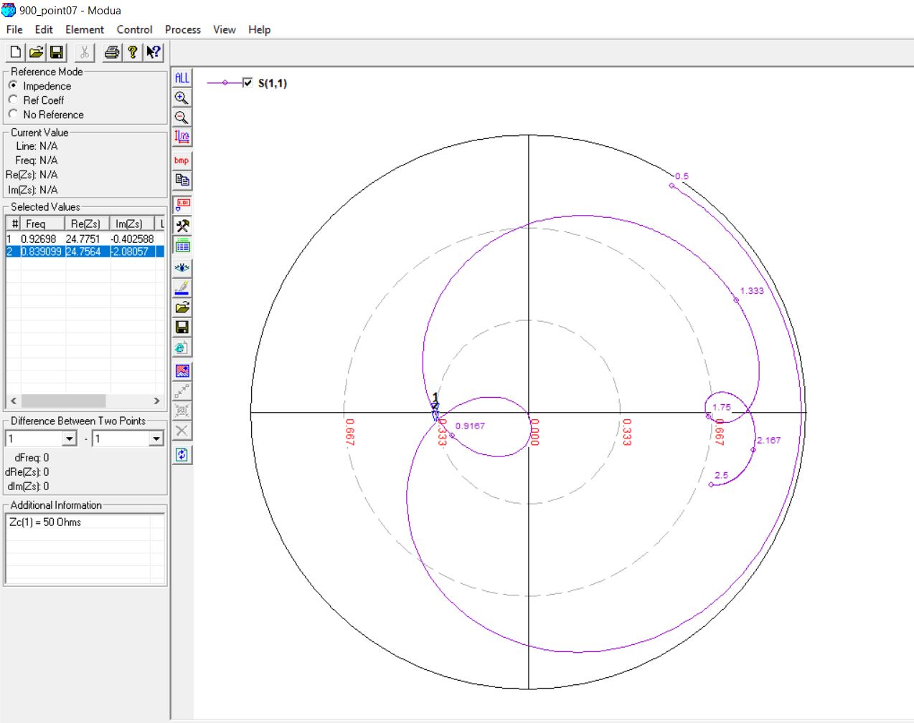

900 MHz, 26mm (0.08 λ)

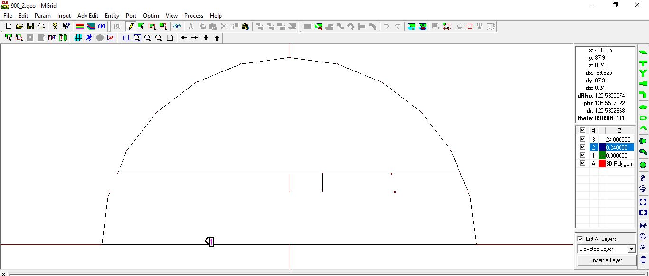

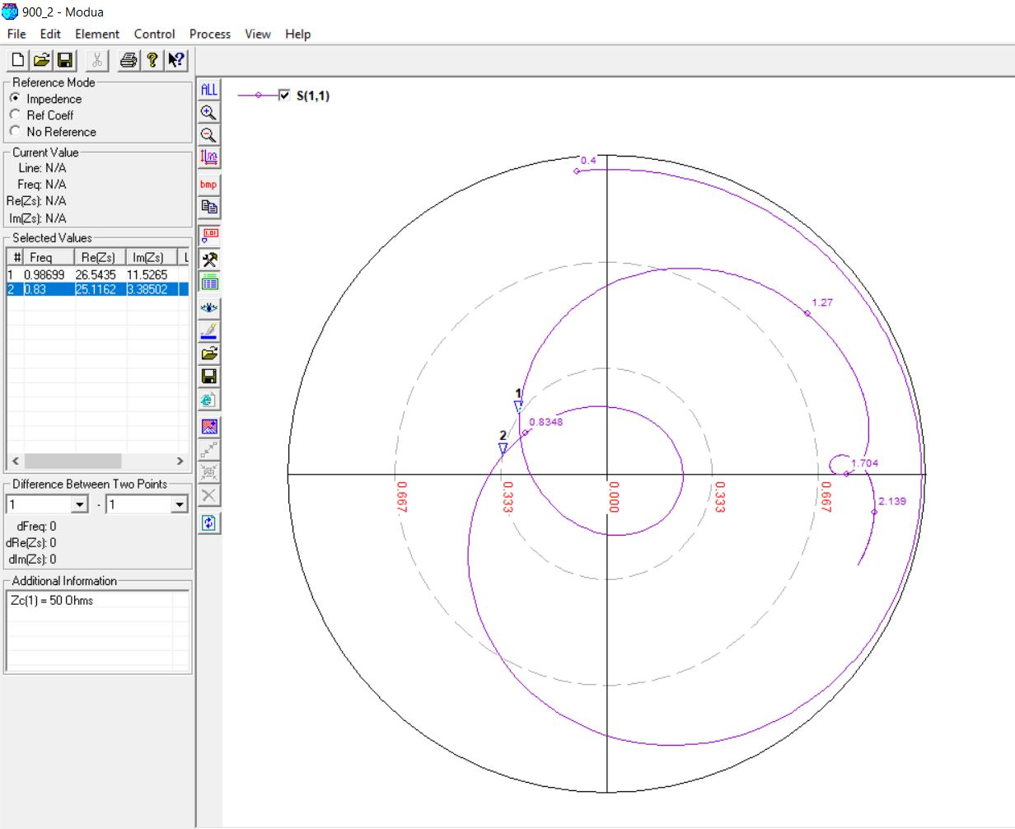

1500 MHz, 10mm (0.06 λ)

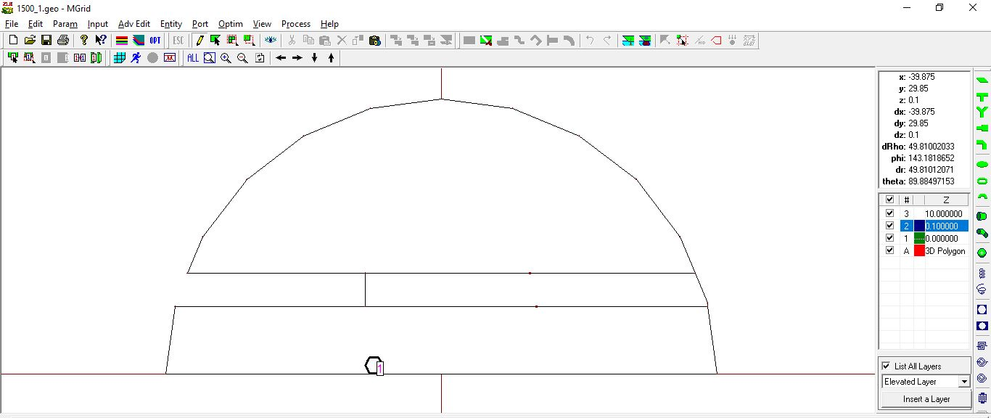

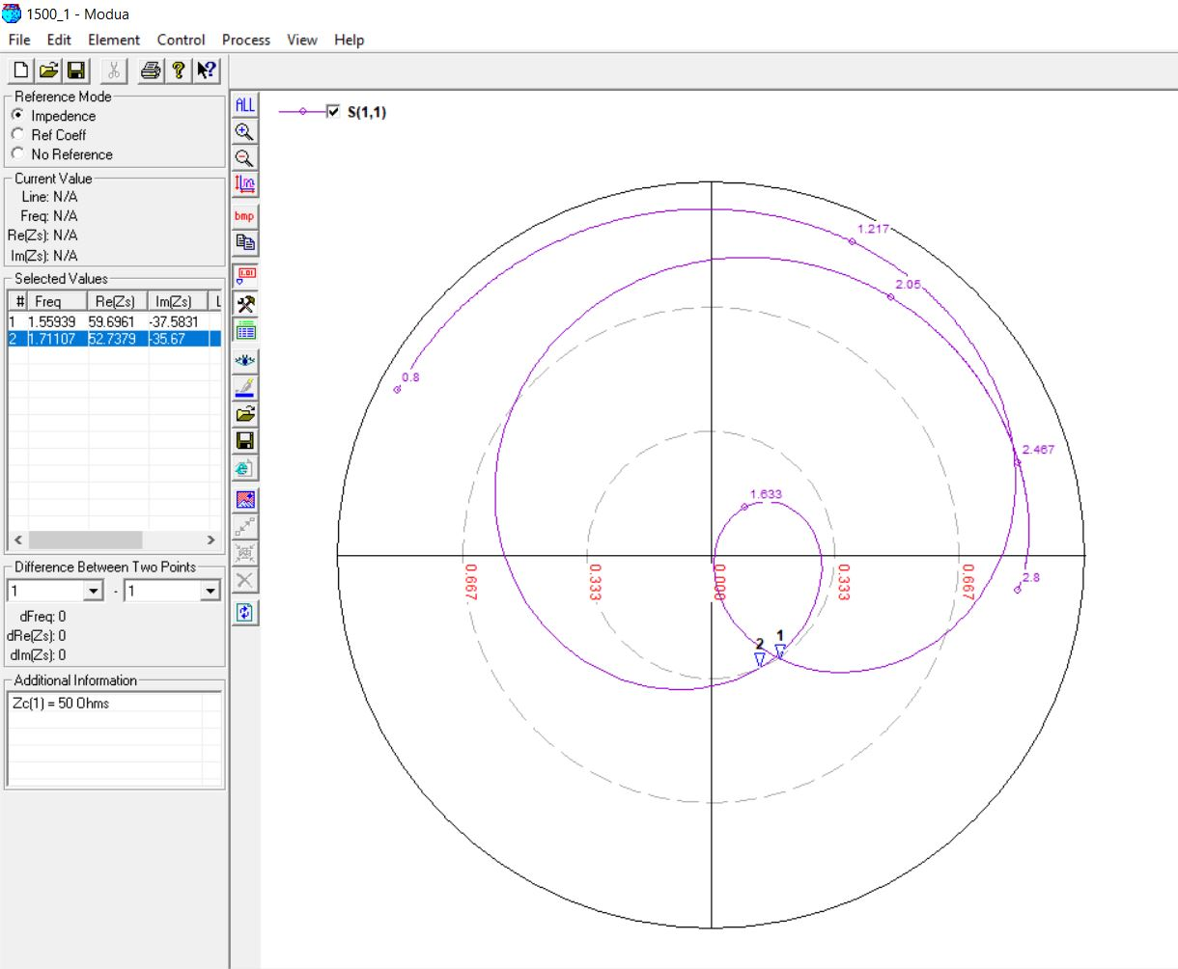

1500 MHz, 14mm (0.07 λ)

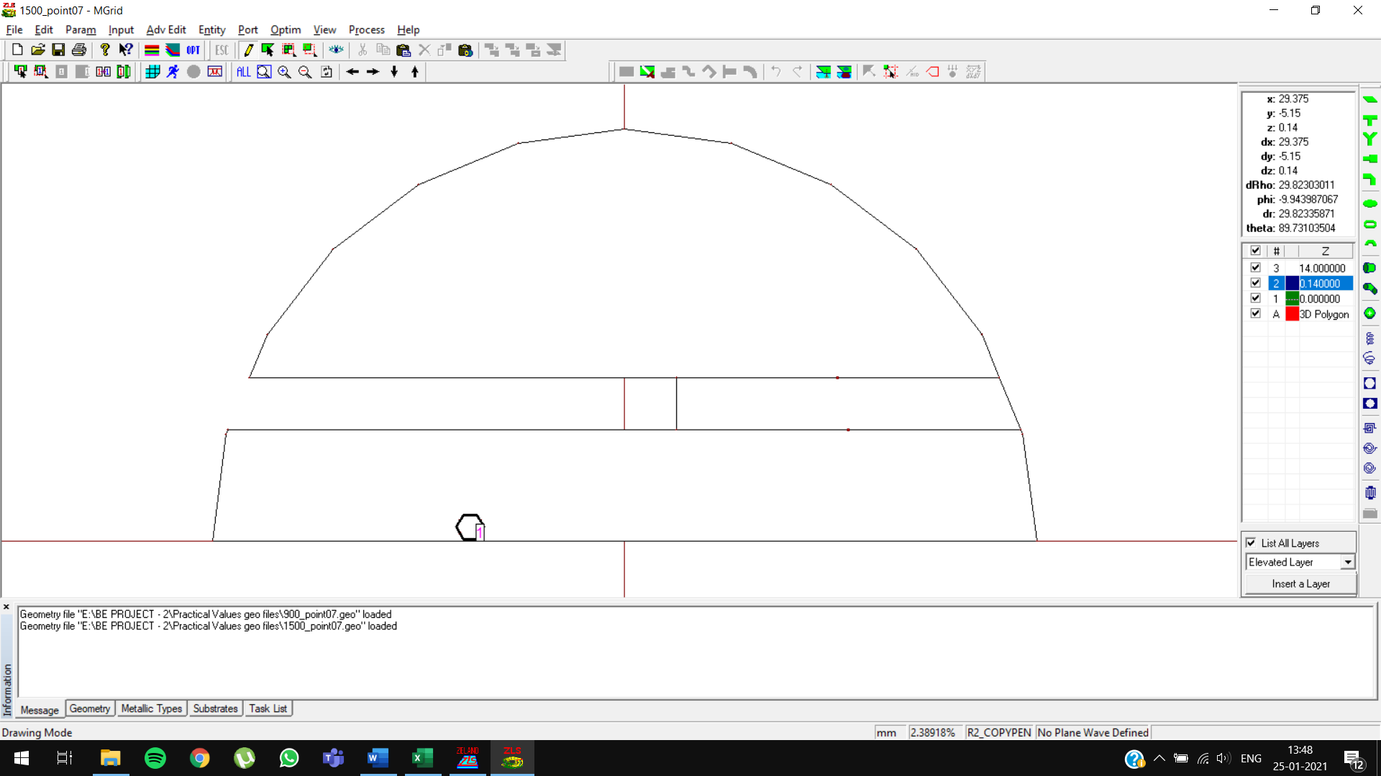

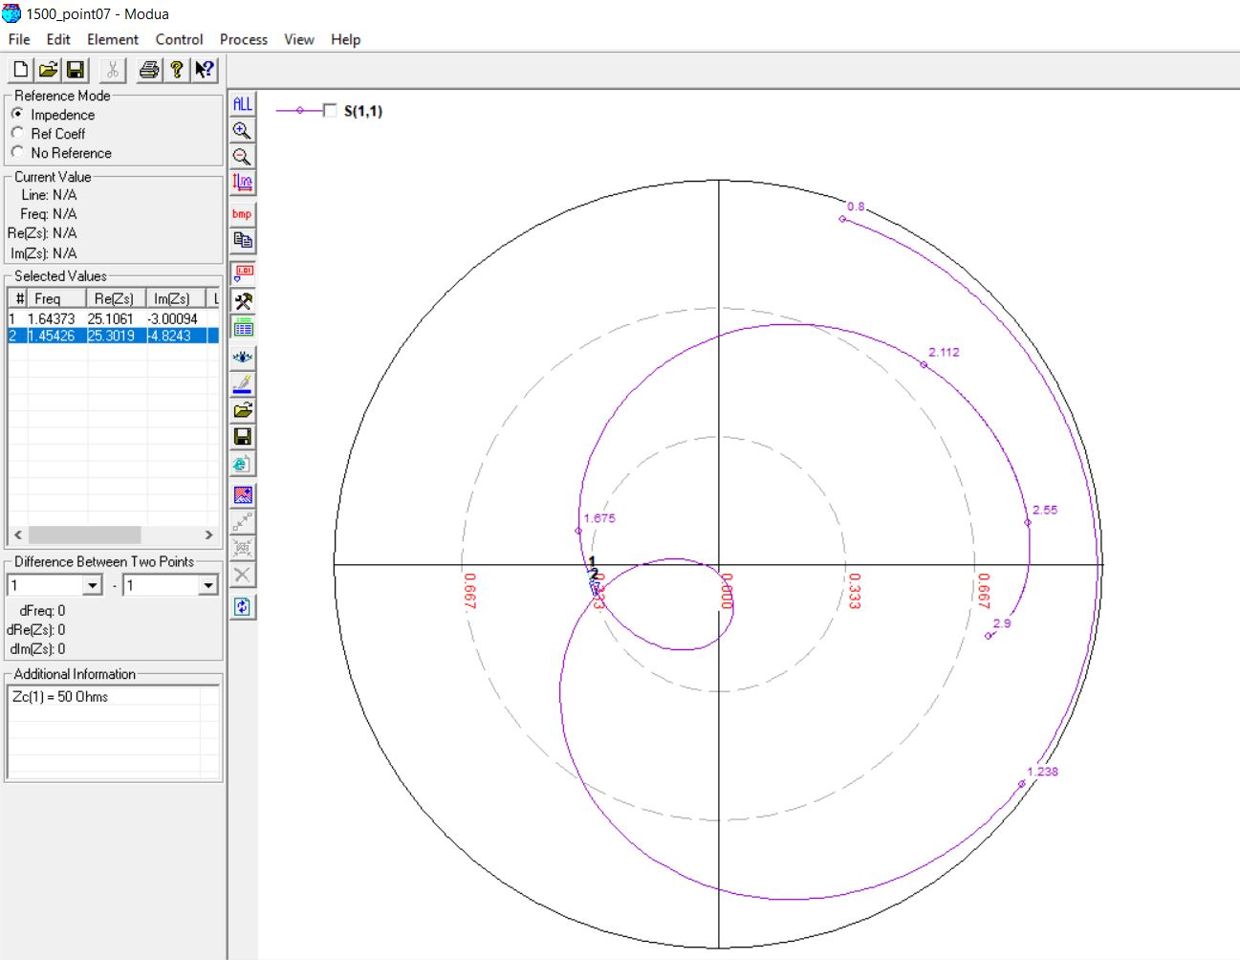

1500 MHz, 15mm (0.08 λ)

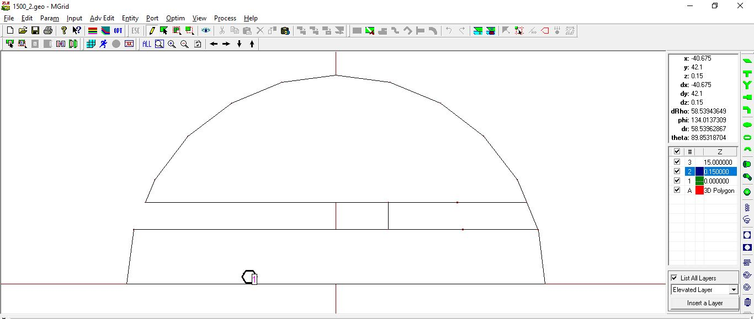

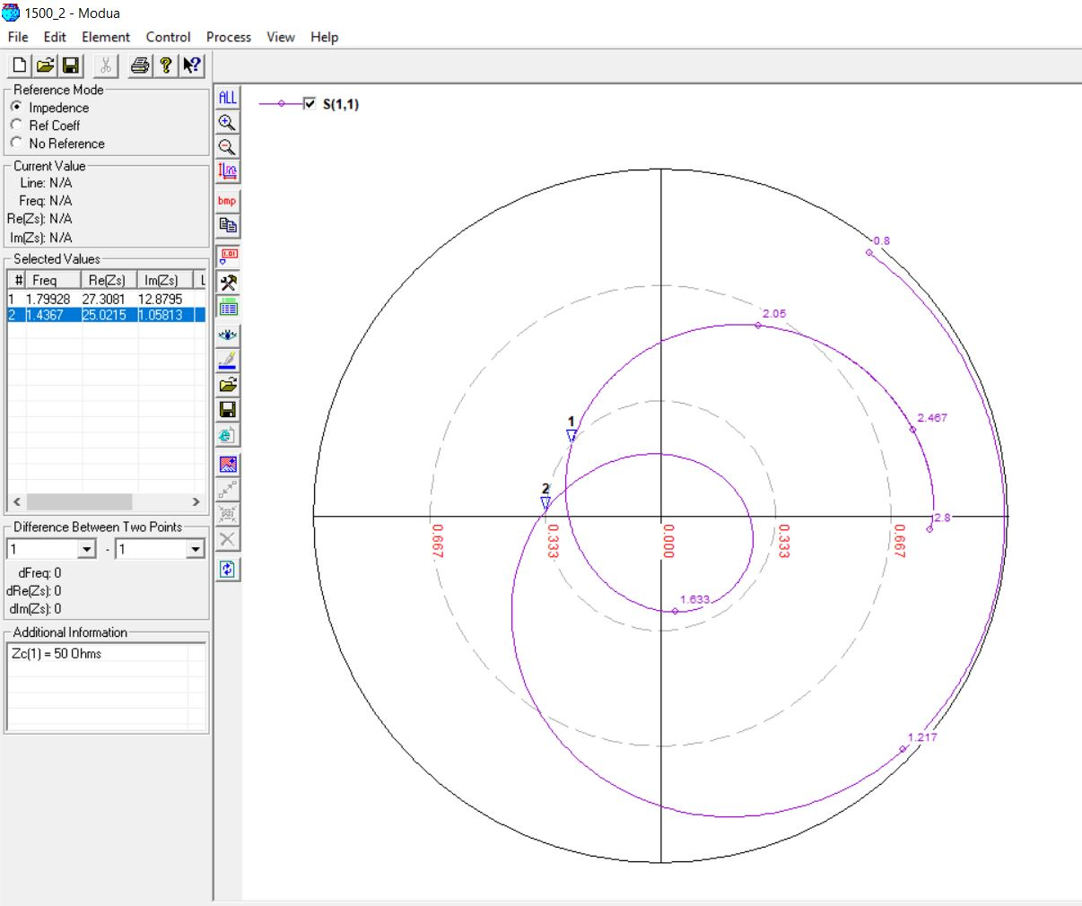

2100 MHz, 7mm (0.06 λ)

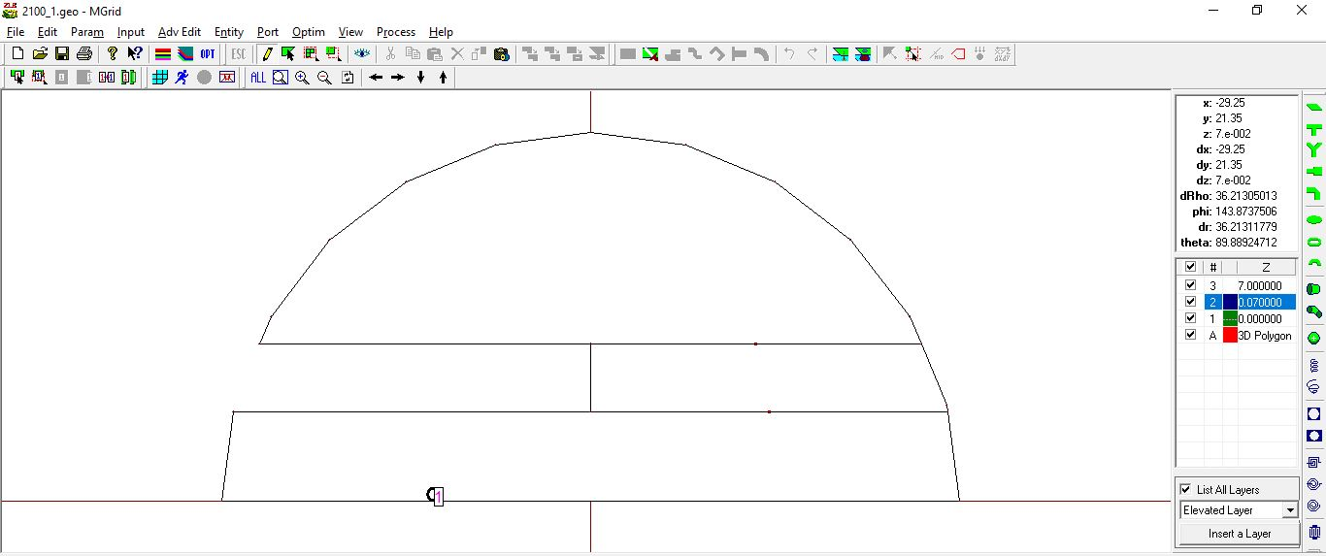

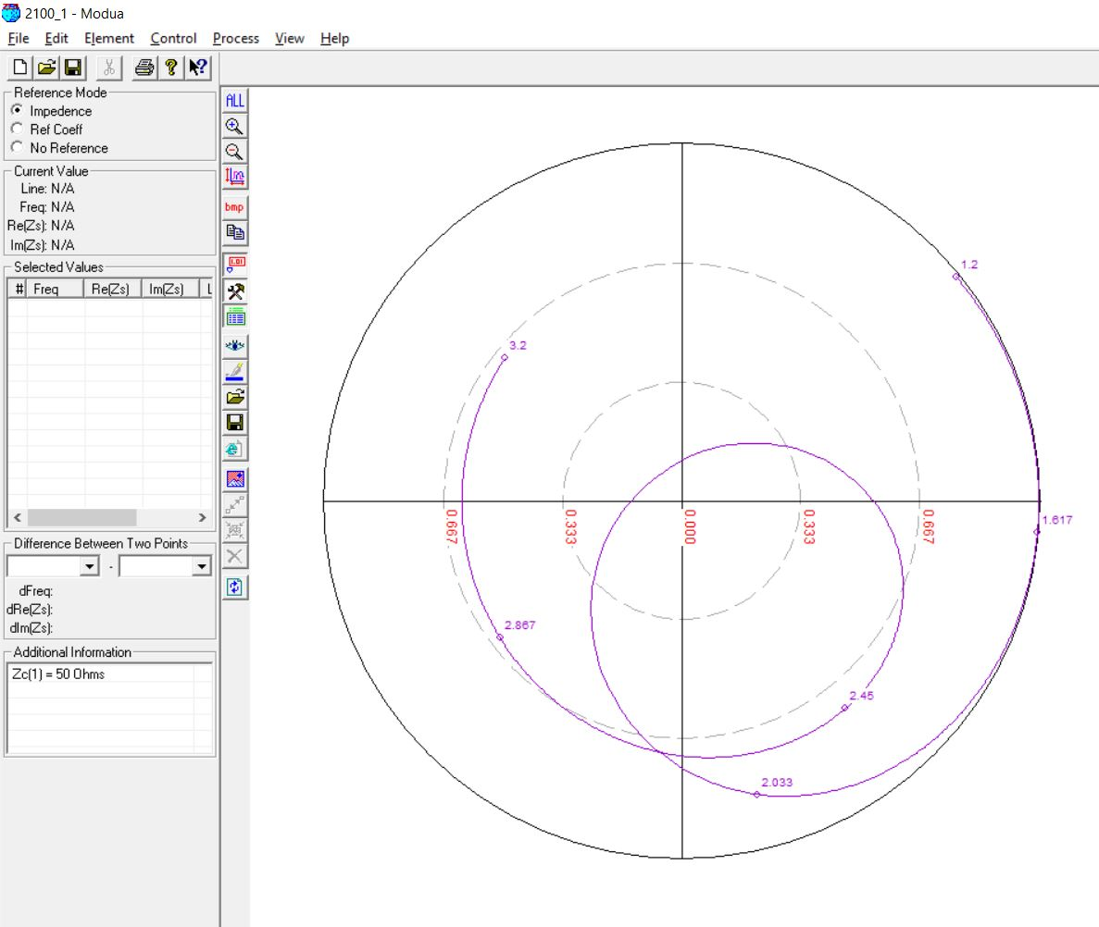

2100 MHz, 10mm (0.07 λ)

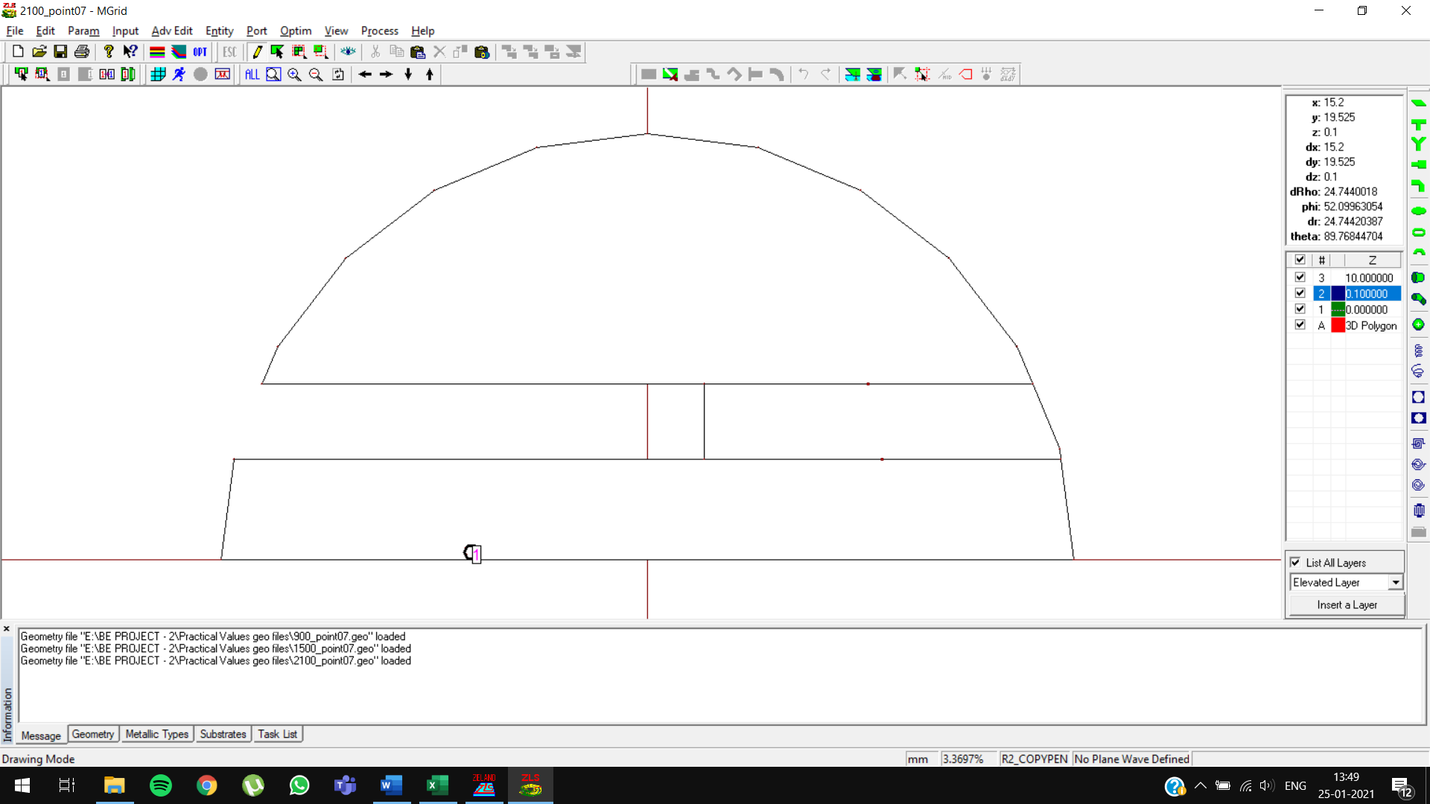

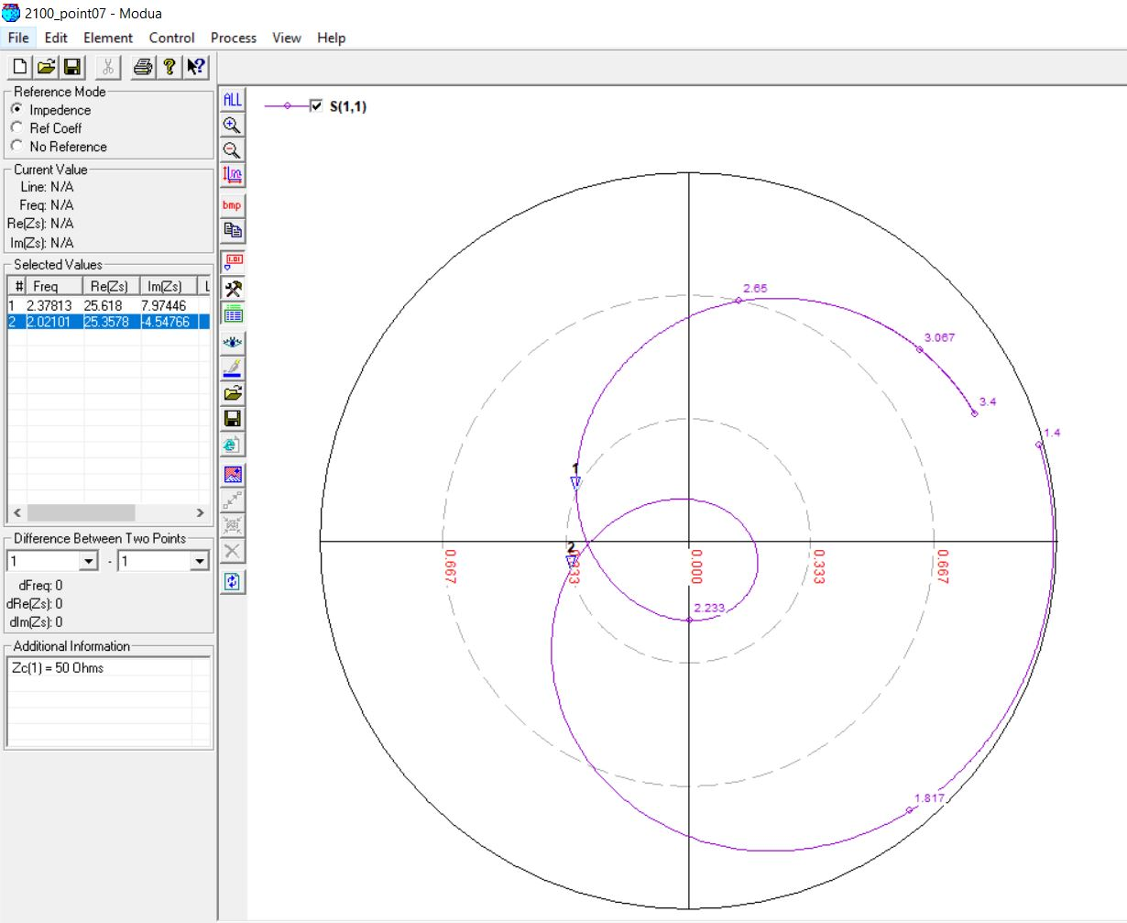

2100 MHz, 11mm (0.08 λ)

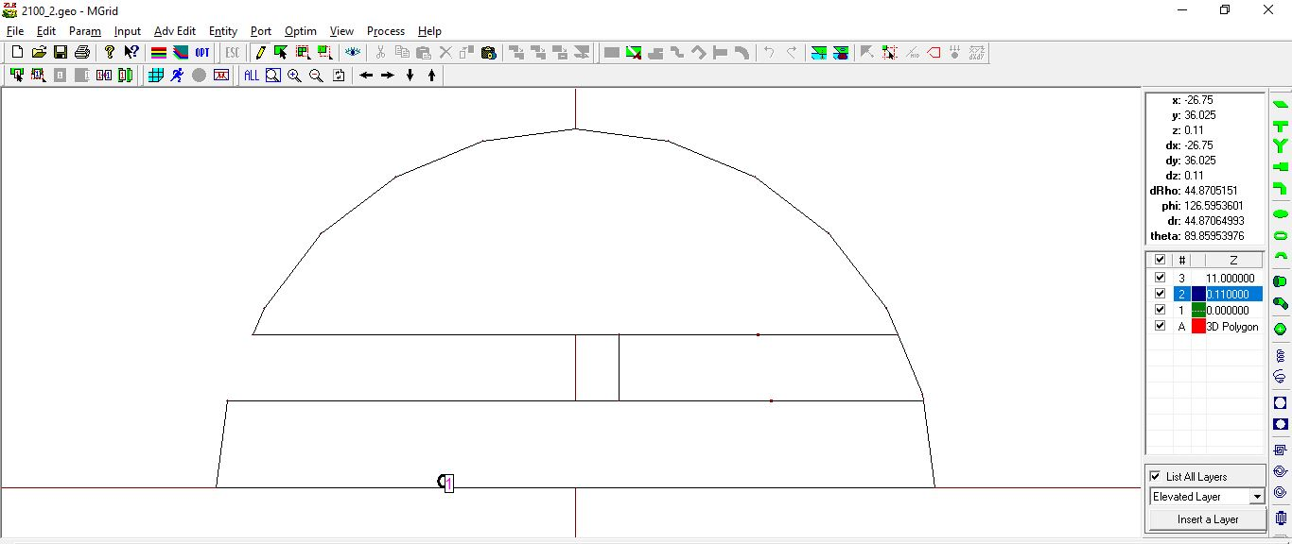

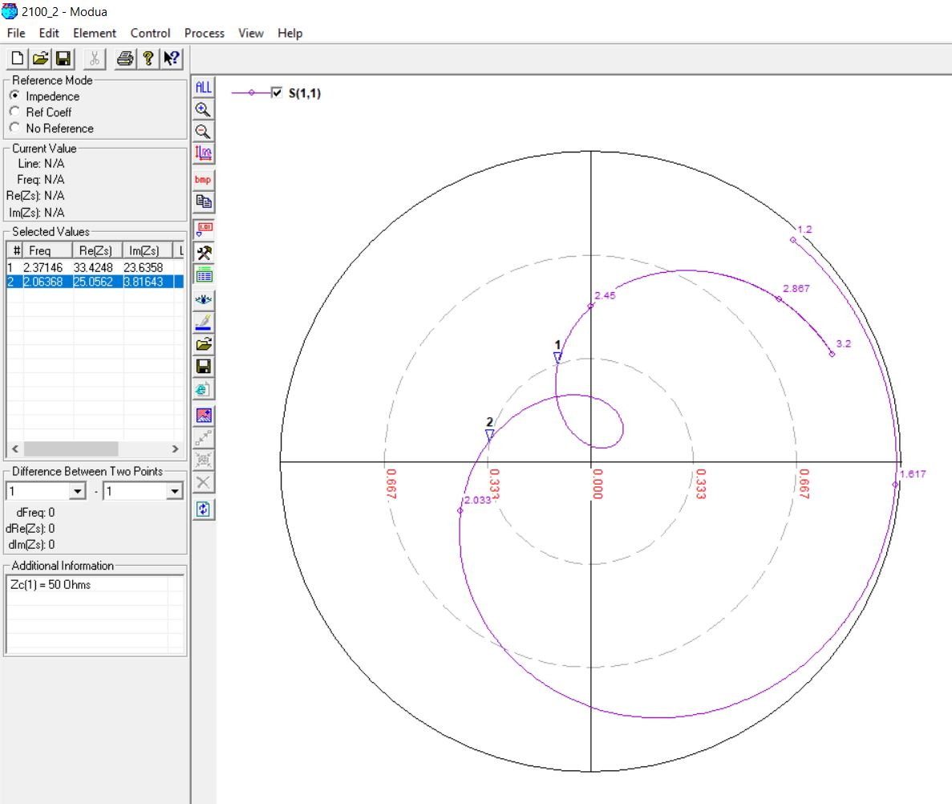

2700 MHz, 5mm (0.06 λ)

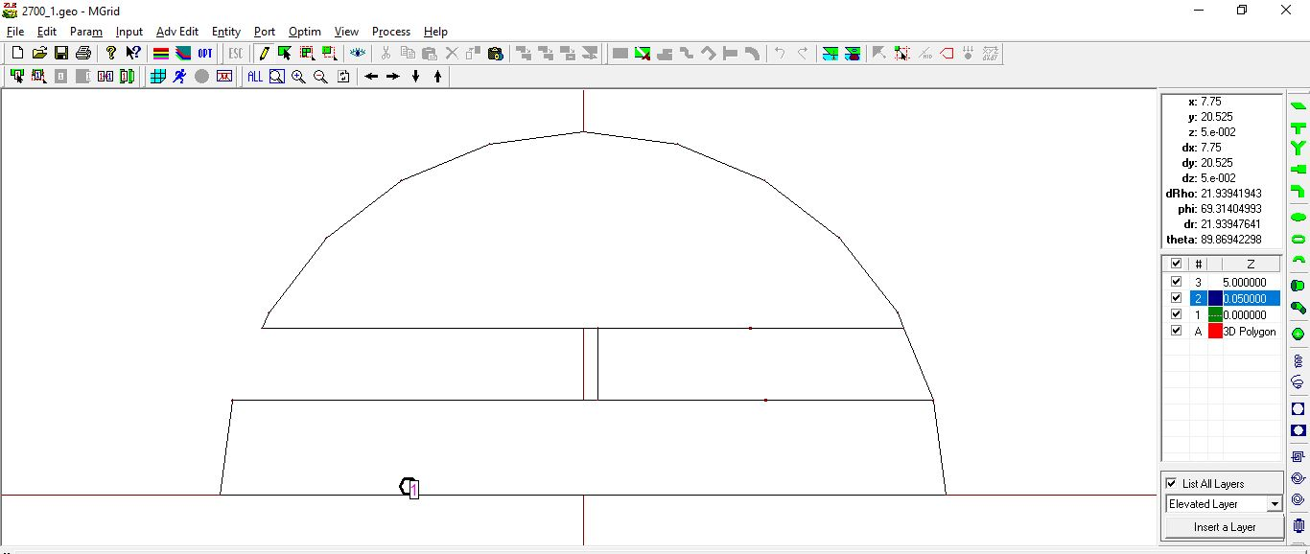

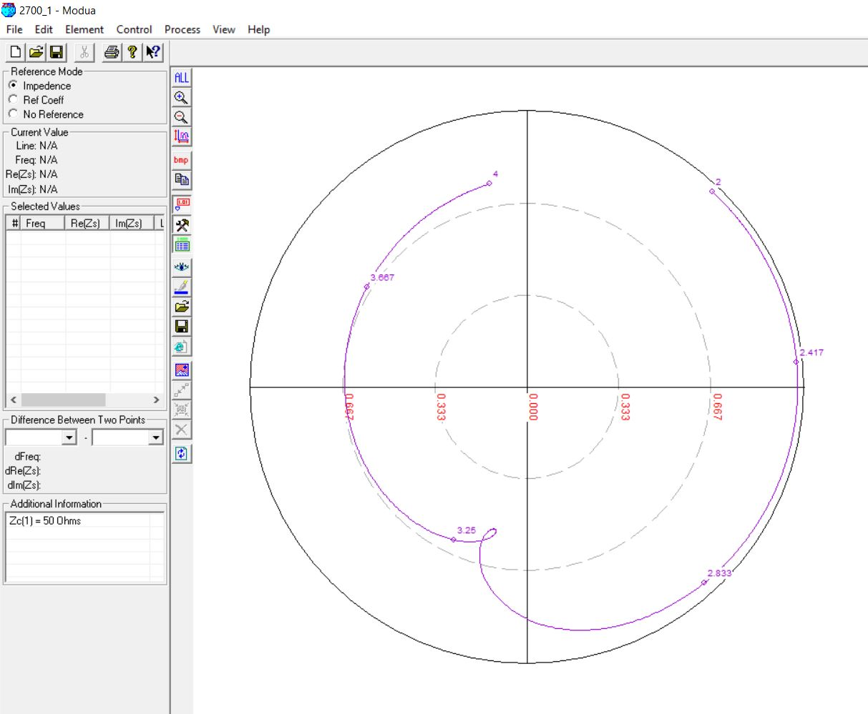

2700 MHz, 5mm (0.07 λ)

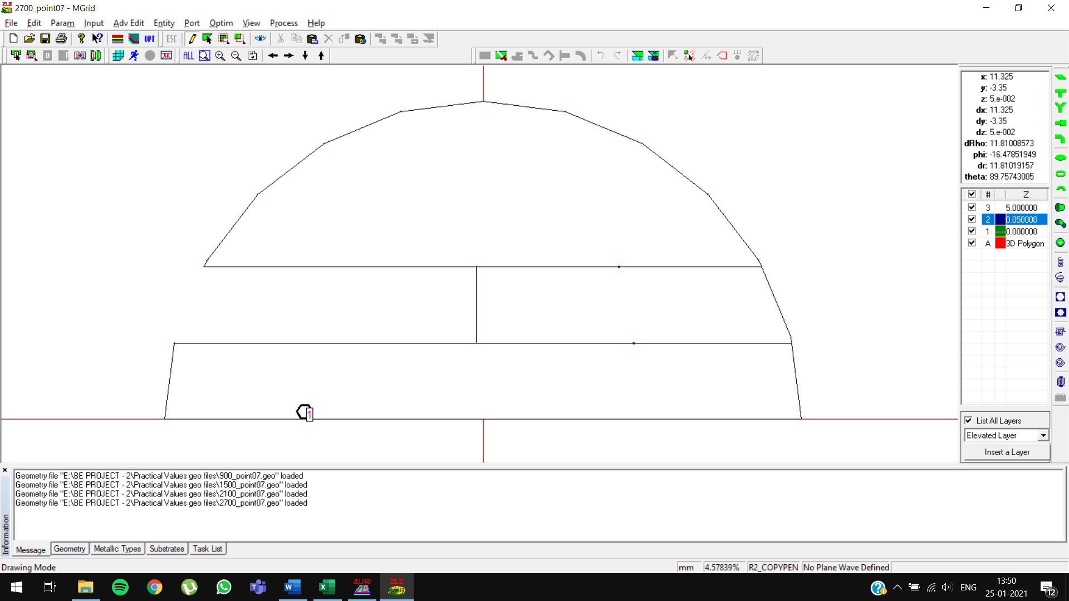

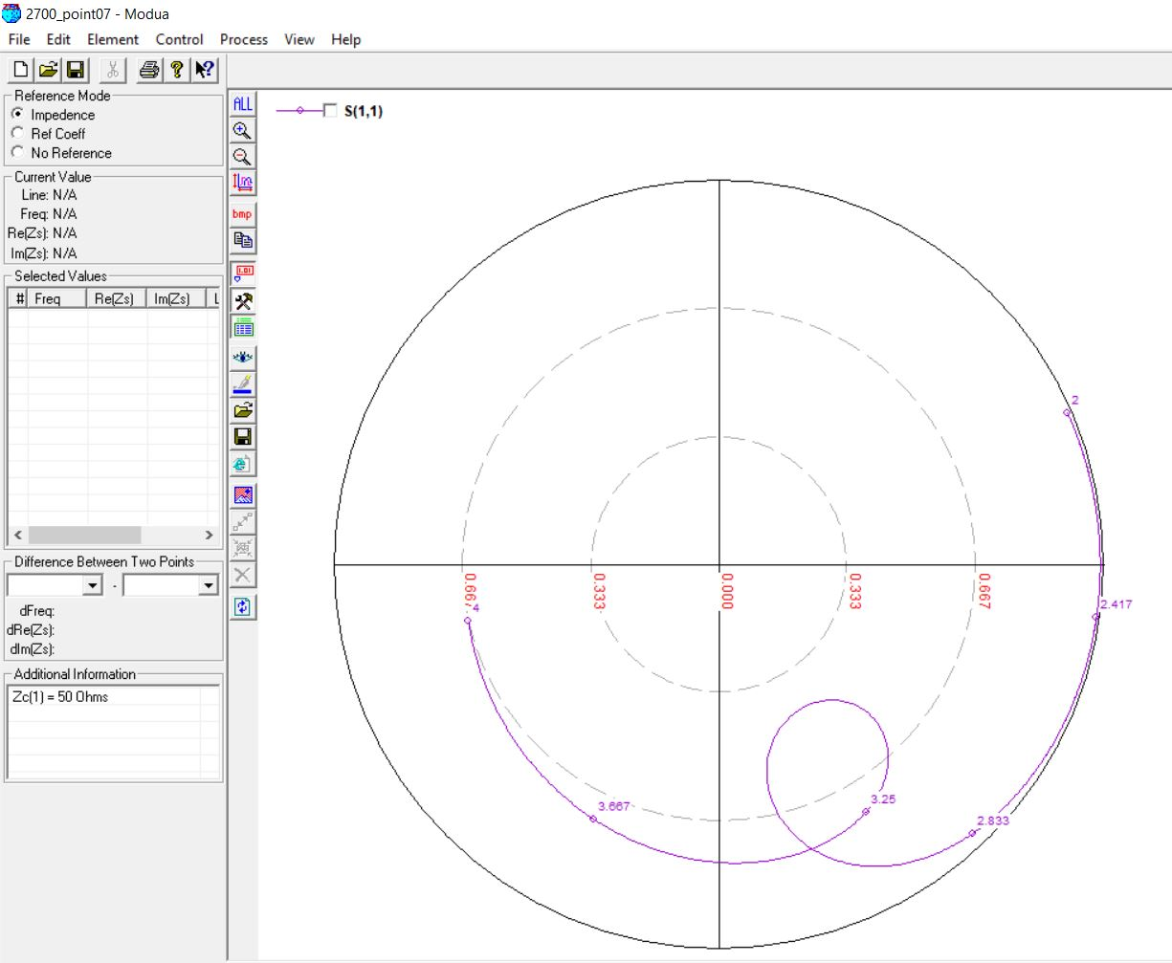

2700 MHz, 7mm (0.08 λ)

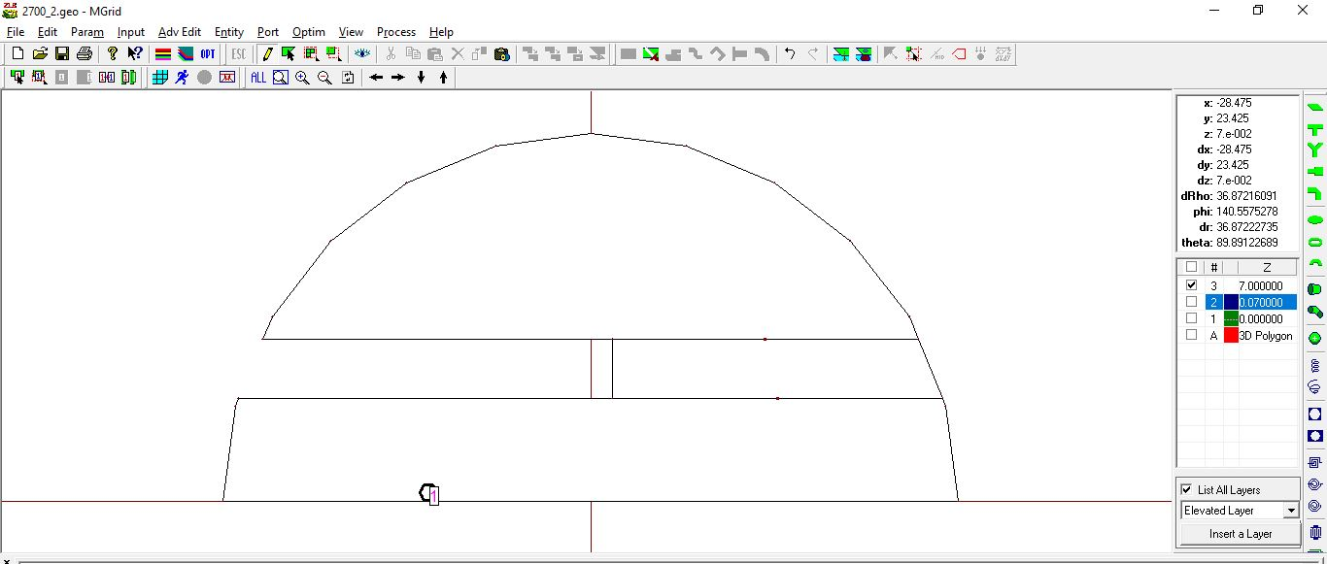

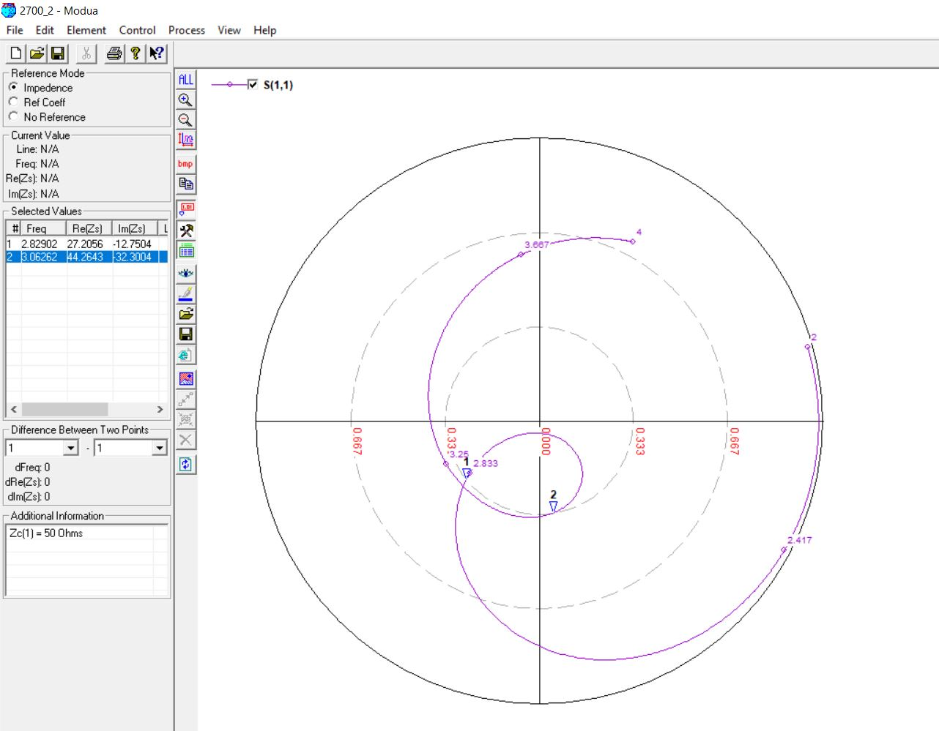

2700 MHz, 7mm (0.08 λ) [OPTIMIZED]

Original Slot Length: 27mm

Optimized Slot Length: 29mm

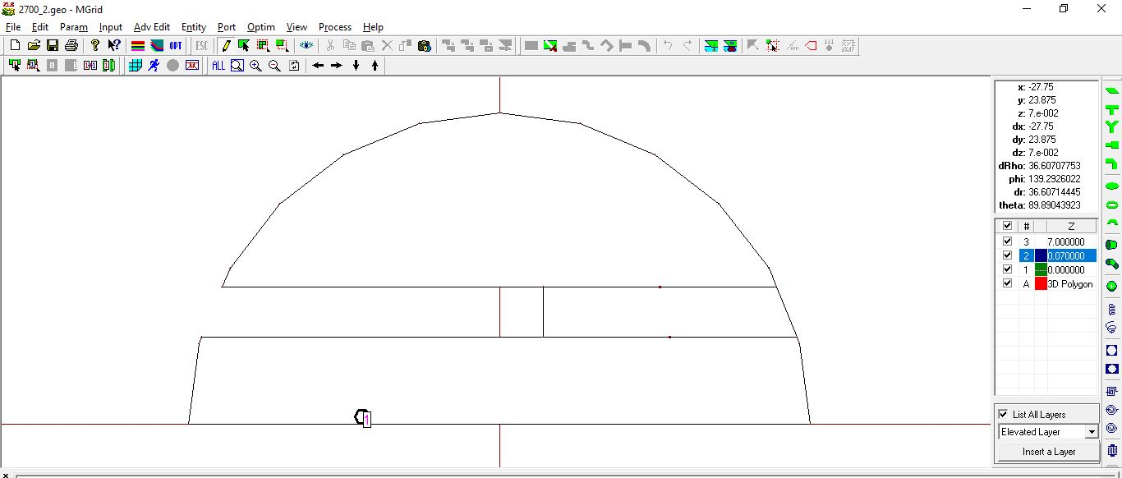

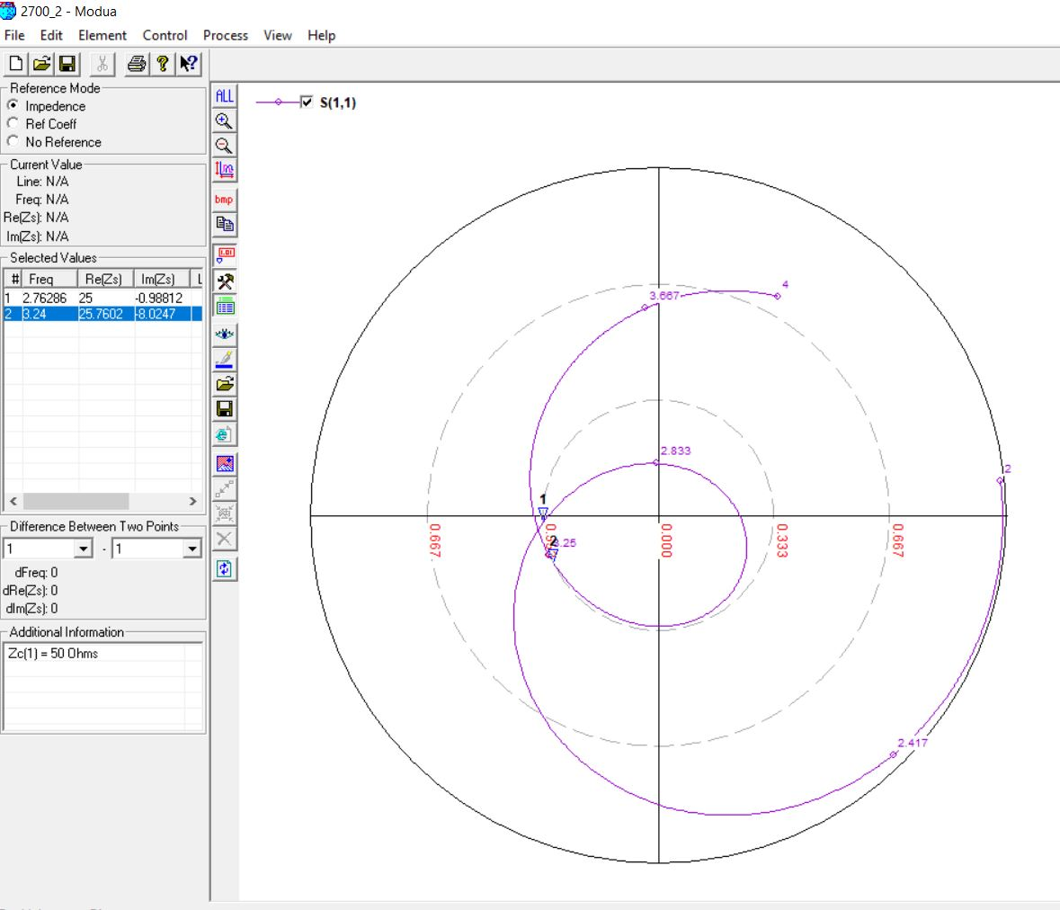

3300 MHz, 6mm (0.06 λ)

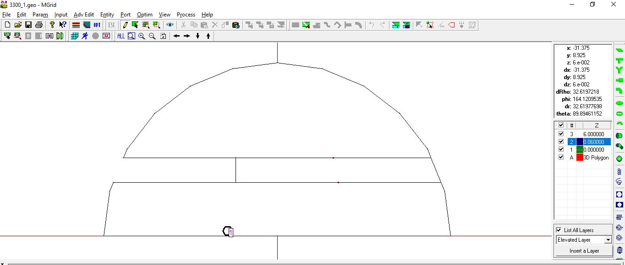

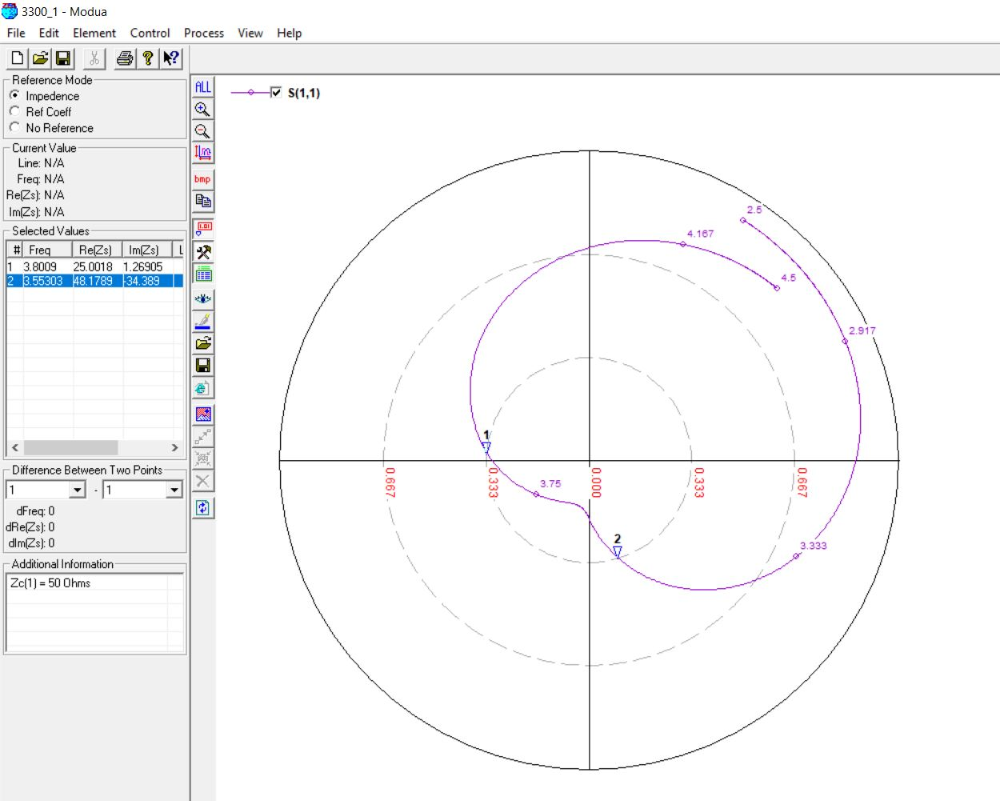

3300 MHz, 6mm (0.06 λ) [OPTIMIZED]

Original Feed Position: -6

Optimized Feed Position: -5

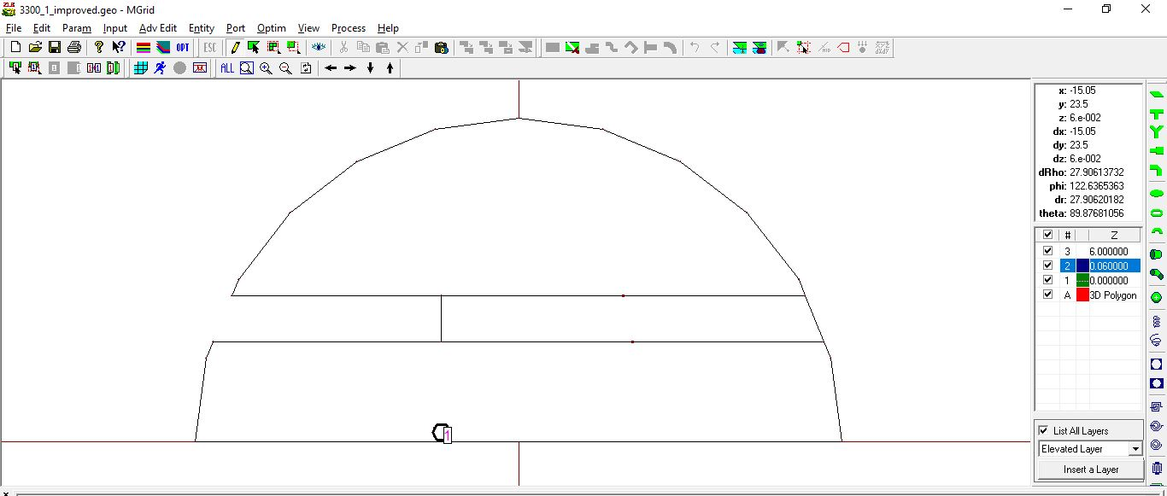

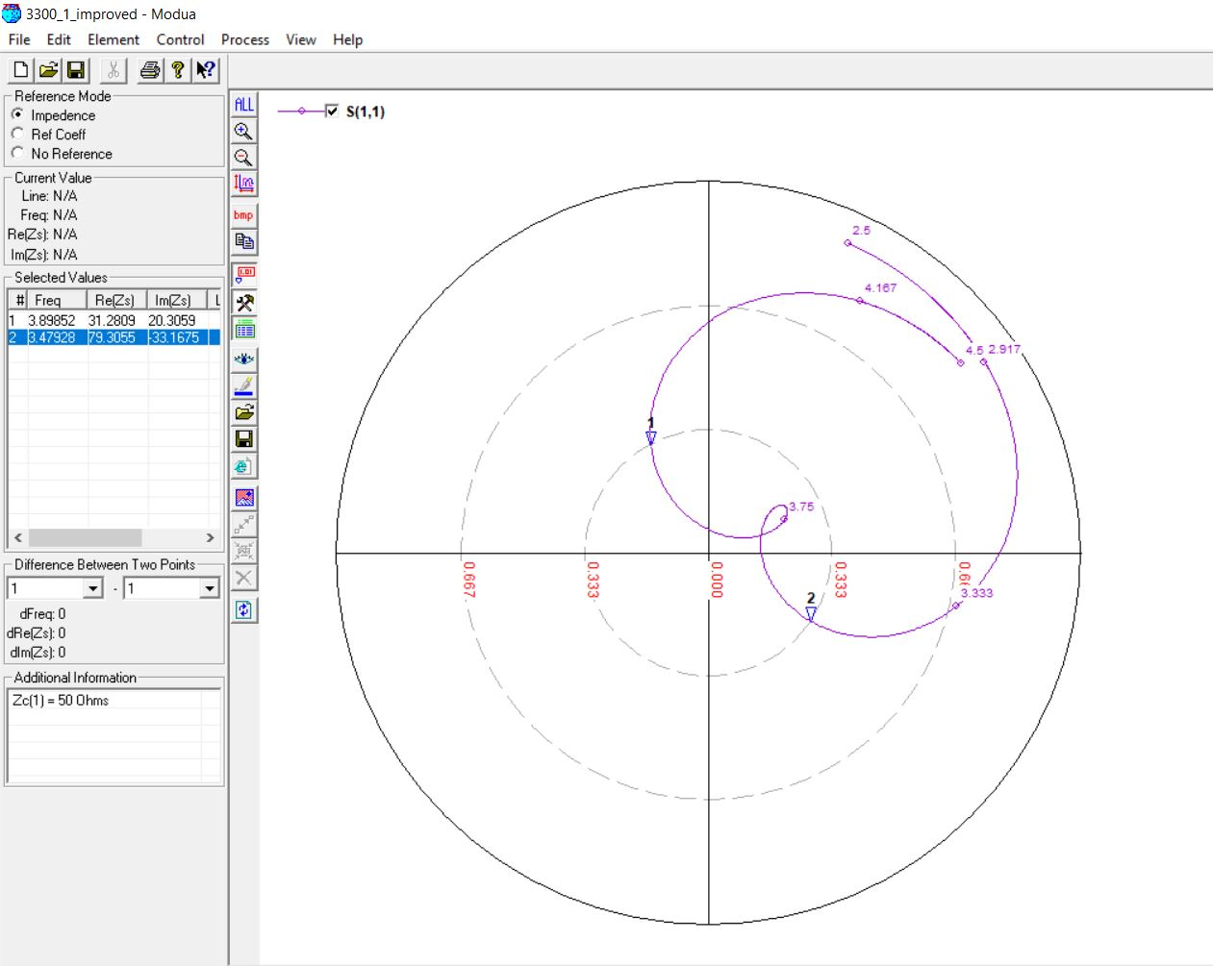

3300 MHz, 6mm (0.07 λ)

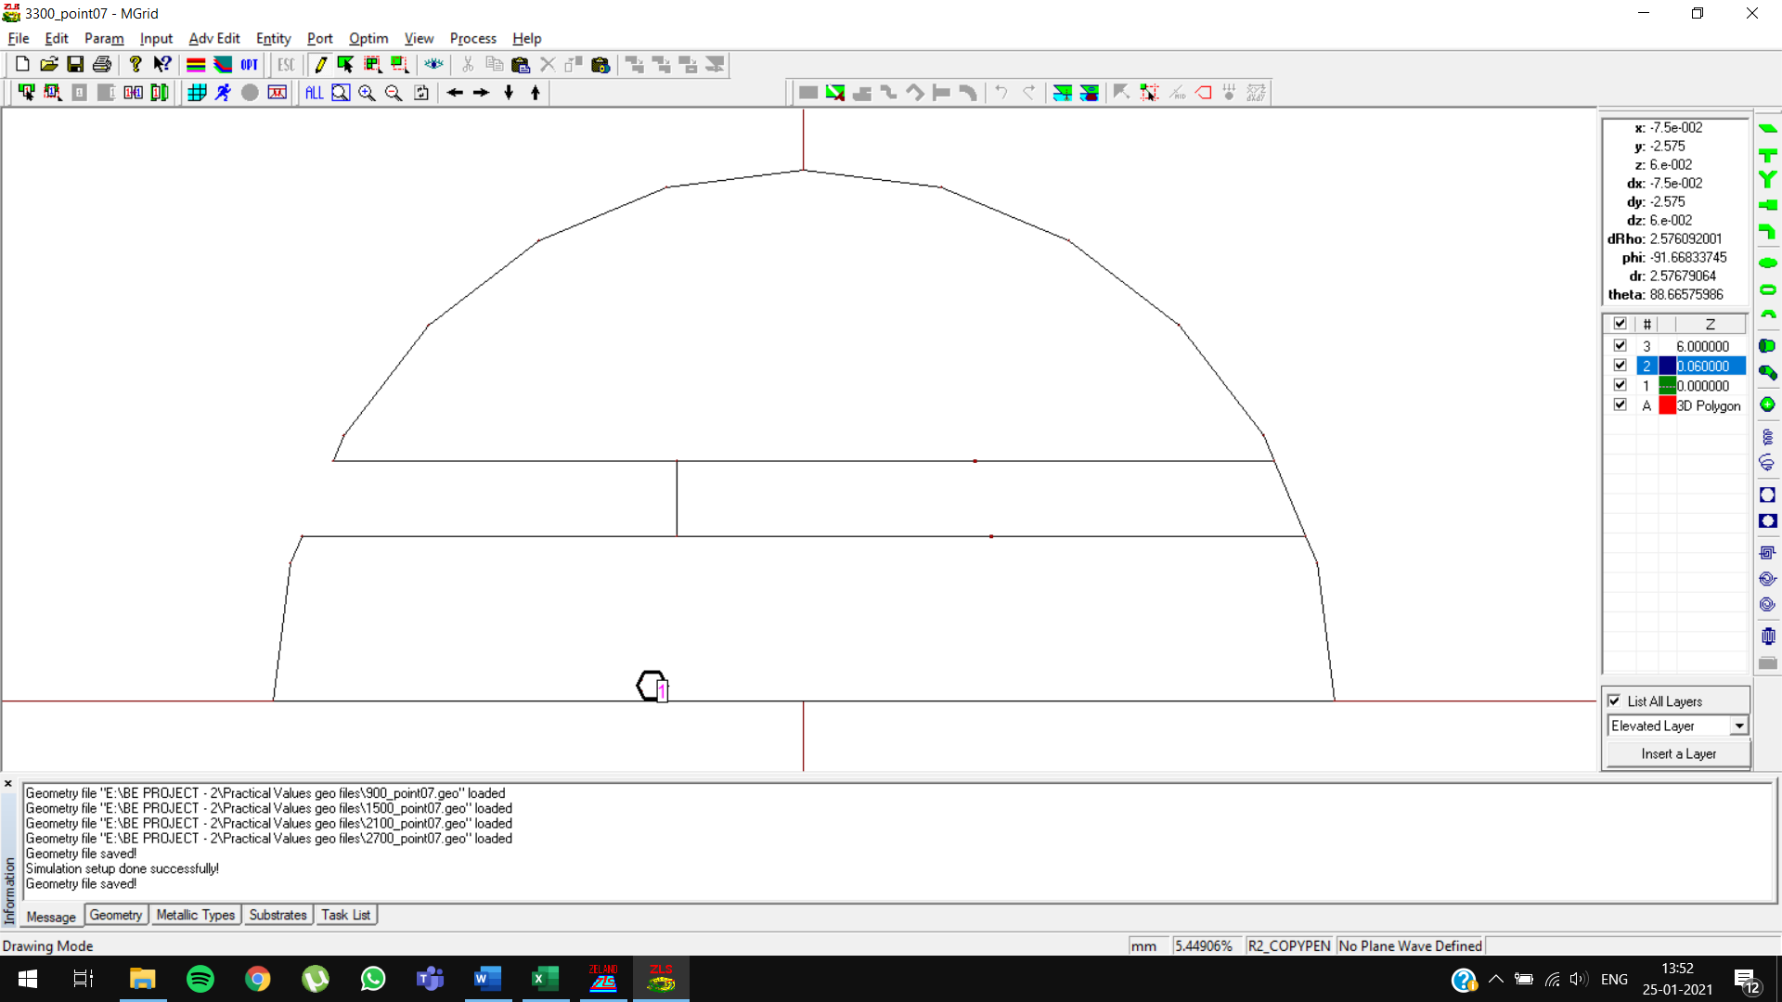

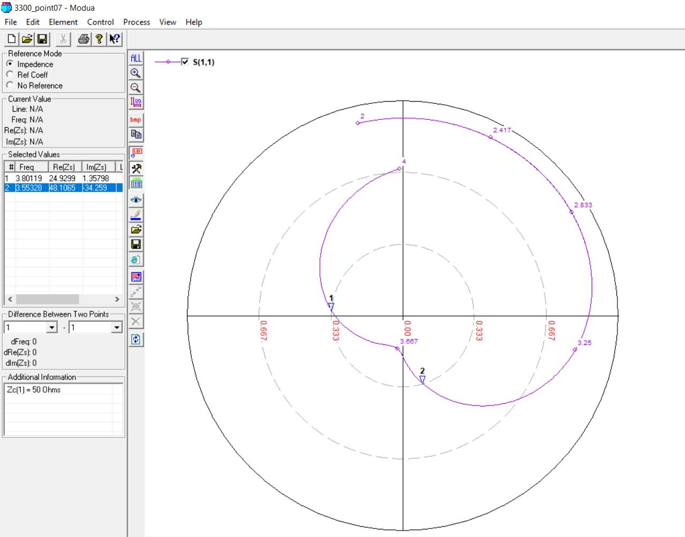

3300 MHz, 6mm (0.07 λ) [OPTIMIZED]

Original Feed Position: -6

Optimized Feed Position: -5

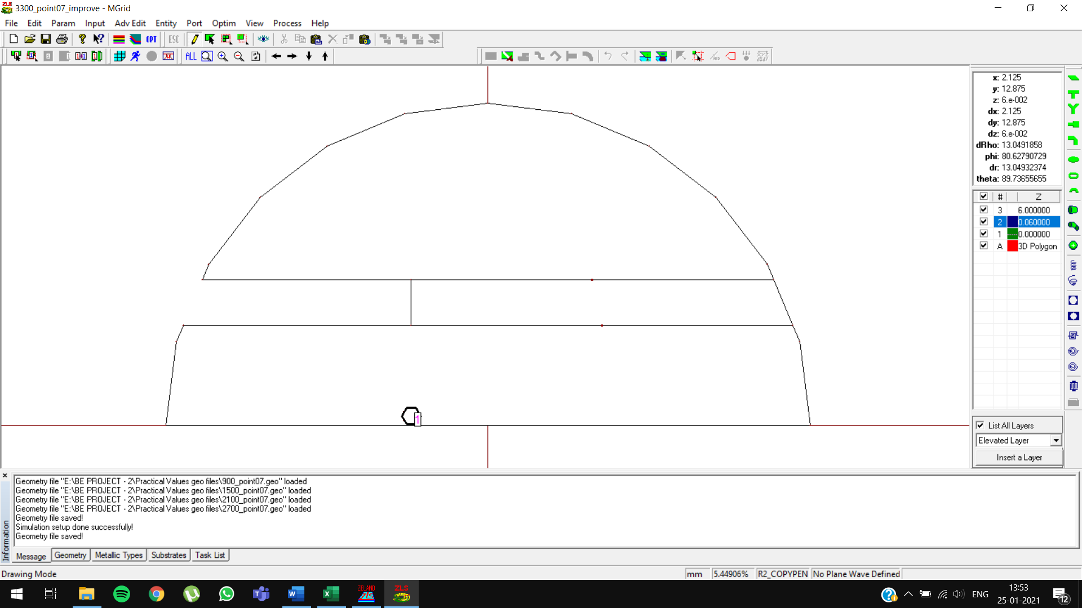

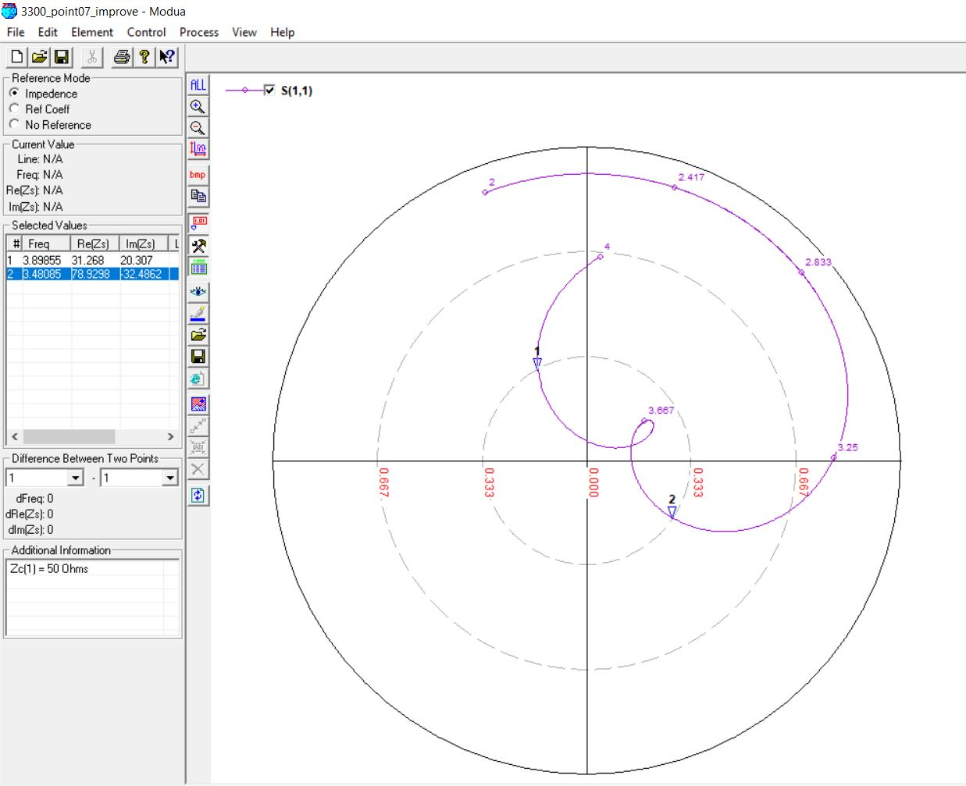

3300 MHz, 6mm (0.08 λ)





3300 MHz, 6mm (0.08 λ) [OPTIMIZED]

Original Feed Position: -6

Optimized Feed Position: -5





3900 MHz, 5mm (0.06 λ)

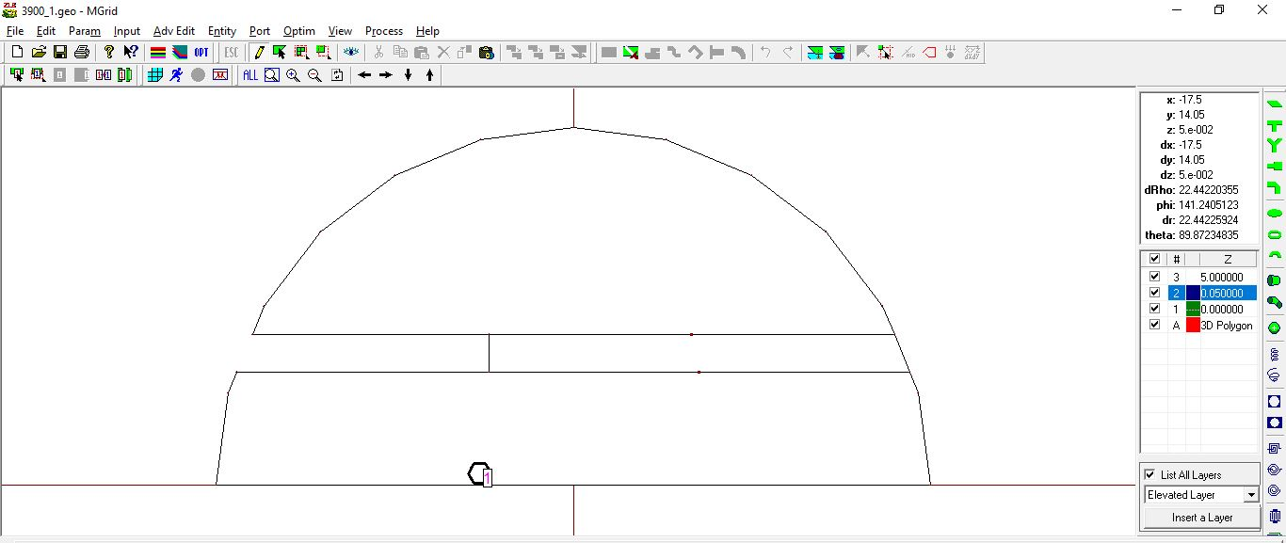

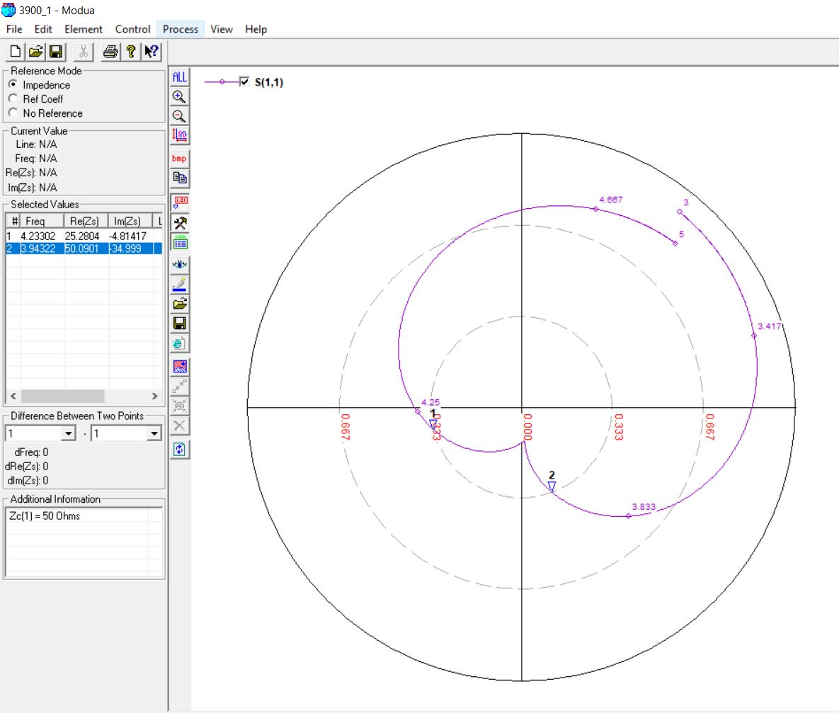

3900 MHz, 5mm (0.06 λ) [OPTIMIZED]

Original Feed Position: -5

Optimized Feed Position: -4

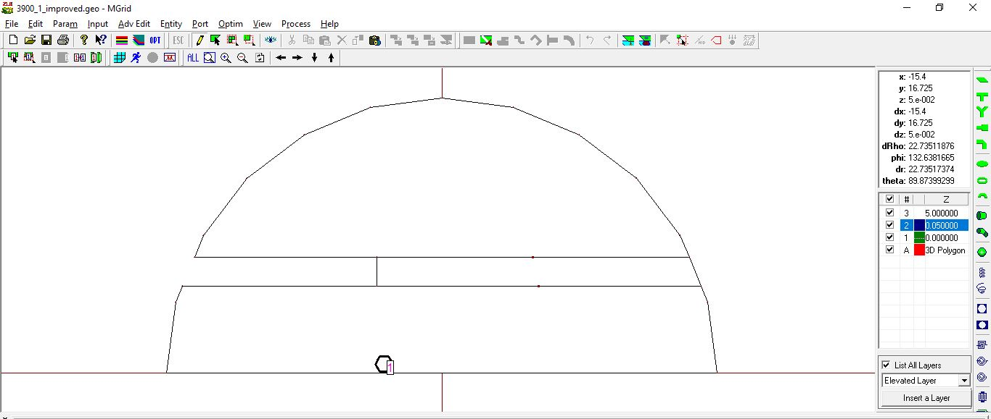

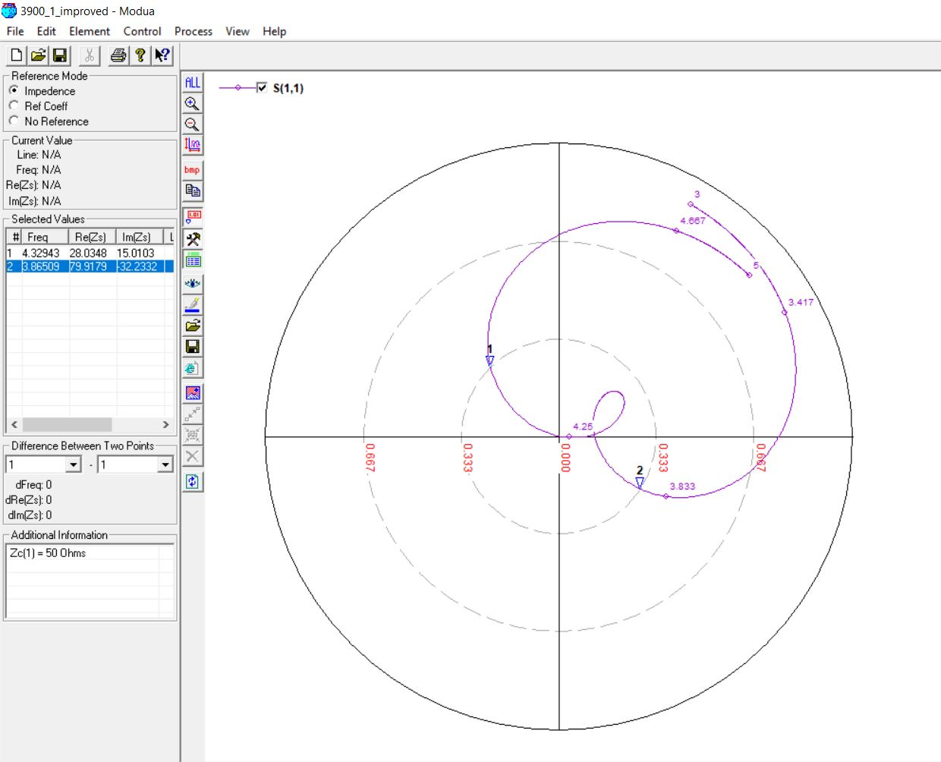

3900 MHz, 5mm (0.07 λ)

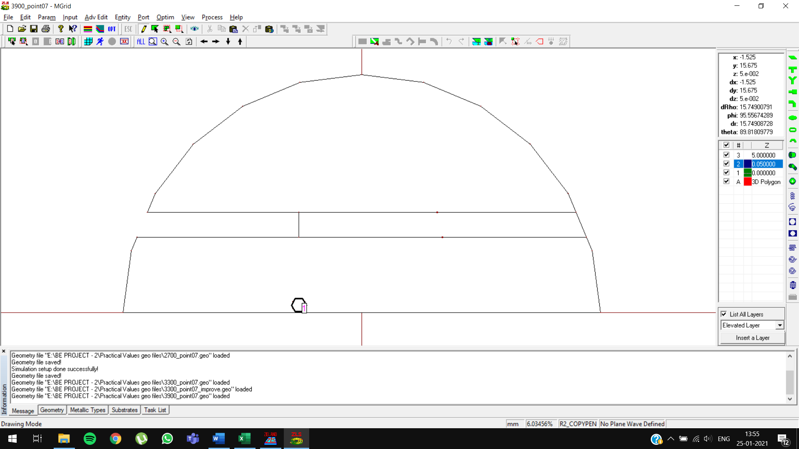

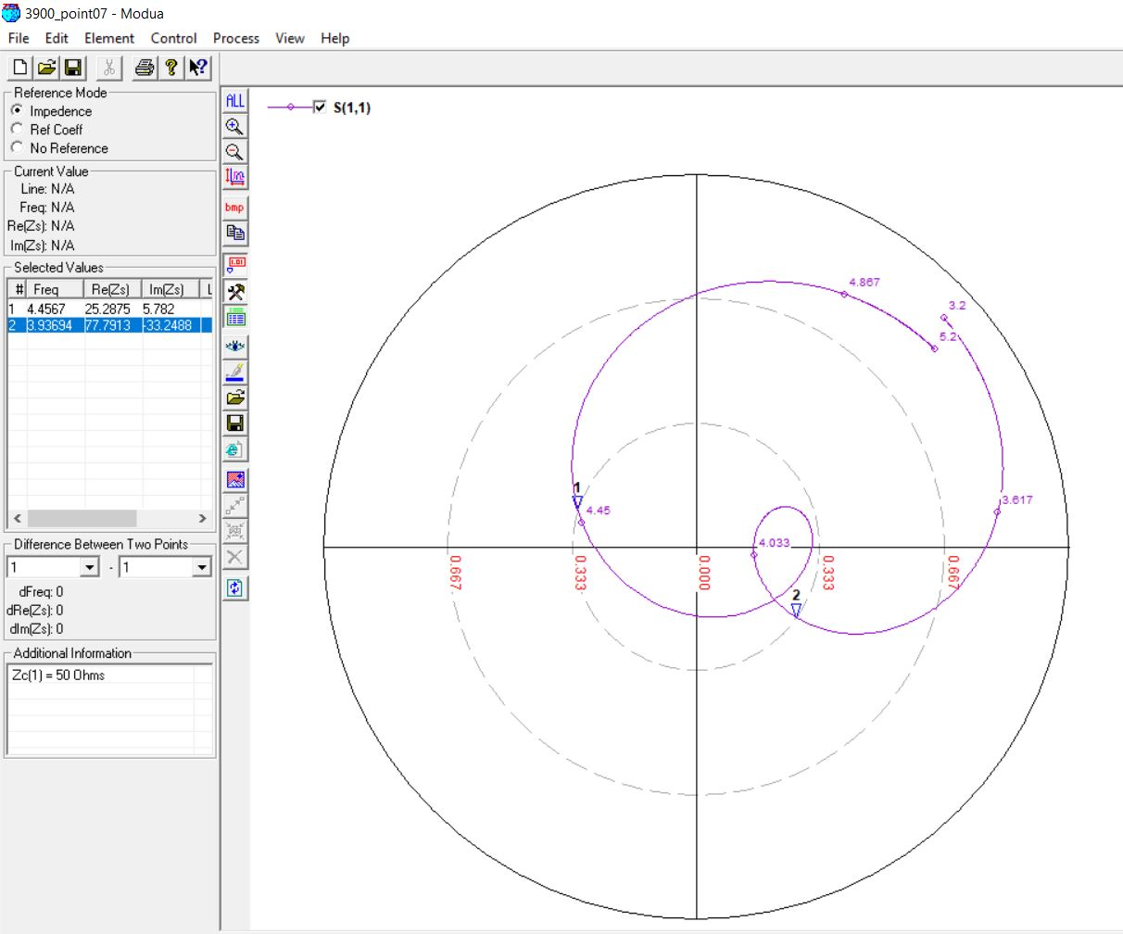

3900 MHz, 5mm (0.08 λ)

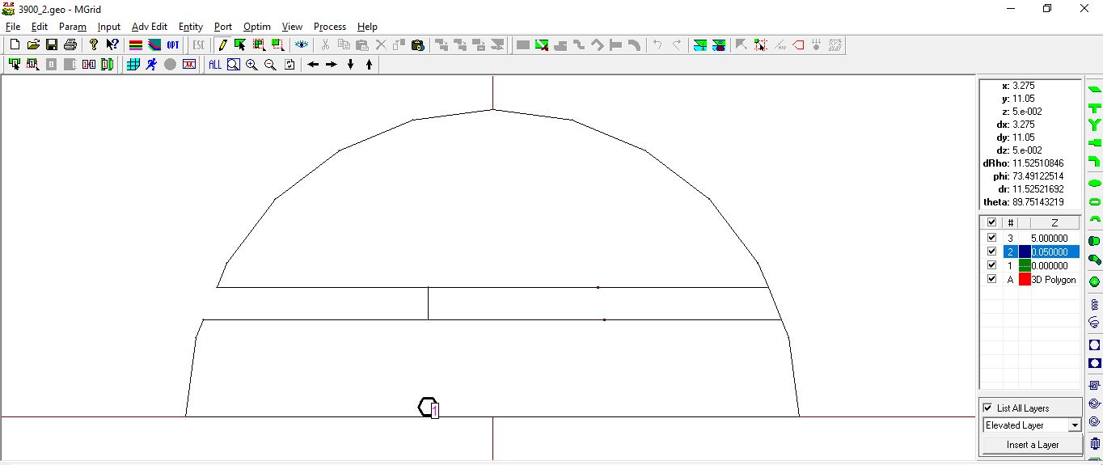

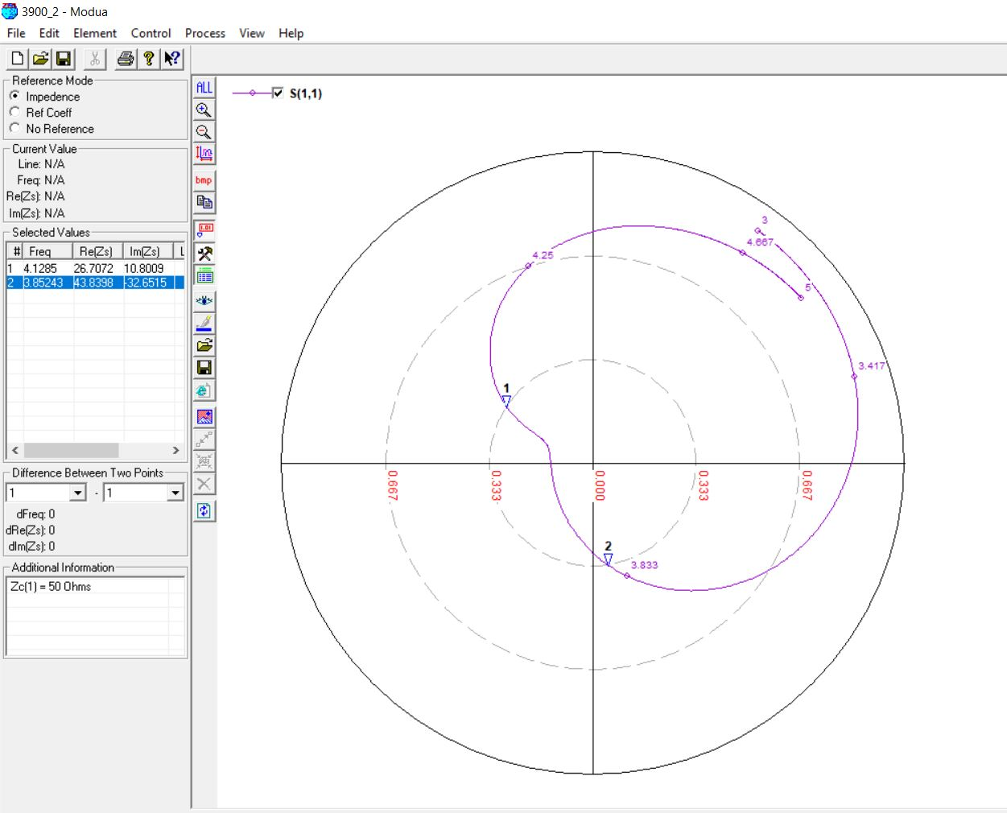

3900 MHz, 5mm (0.08 λ) [OPTIMIZED]

Original Slot Length: 15mm, Original Feed Position: -4

Optimized Slot Length: 14mm, Optimized Feed Position: -5

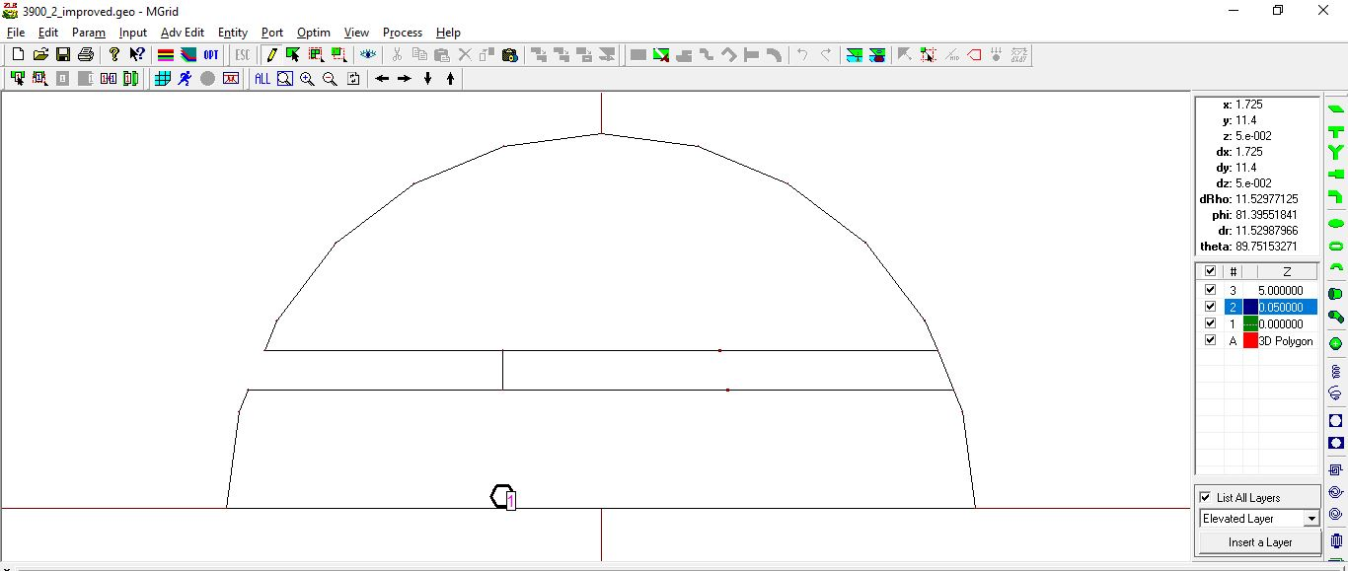

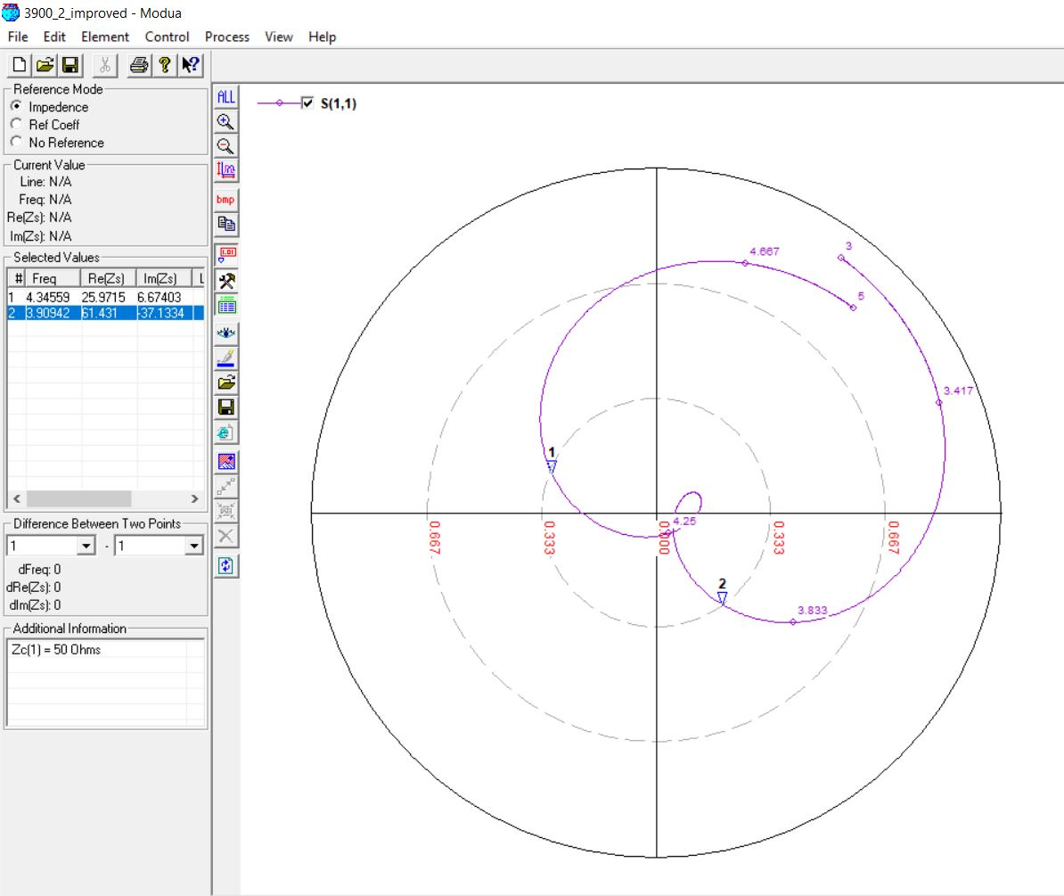

4300 MHz, 5mm (0.06 λ)

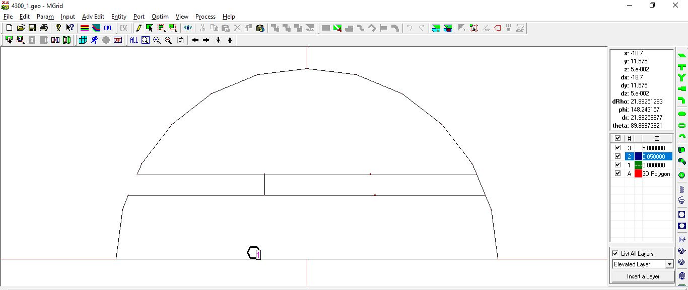

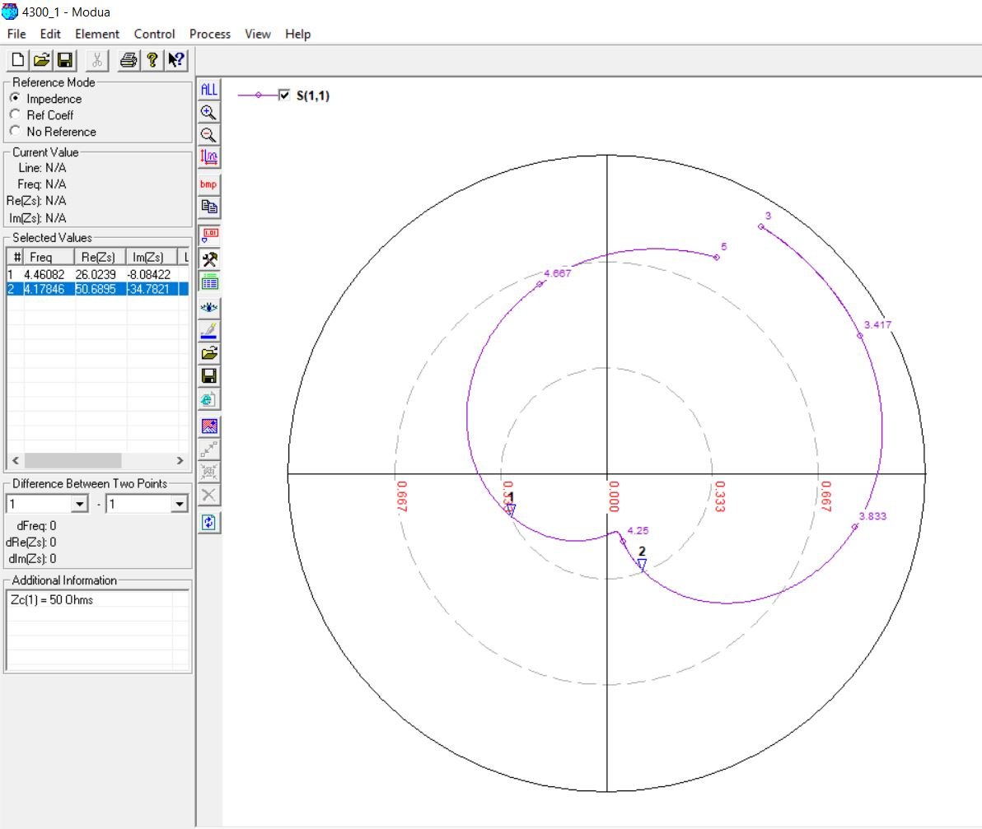

4300 MHz, 5mm (0.06 λ) [OPTIMIZED]

Original Feed Position: -5

Optimized Feed Position: -4

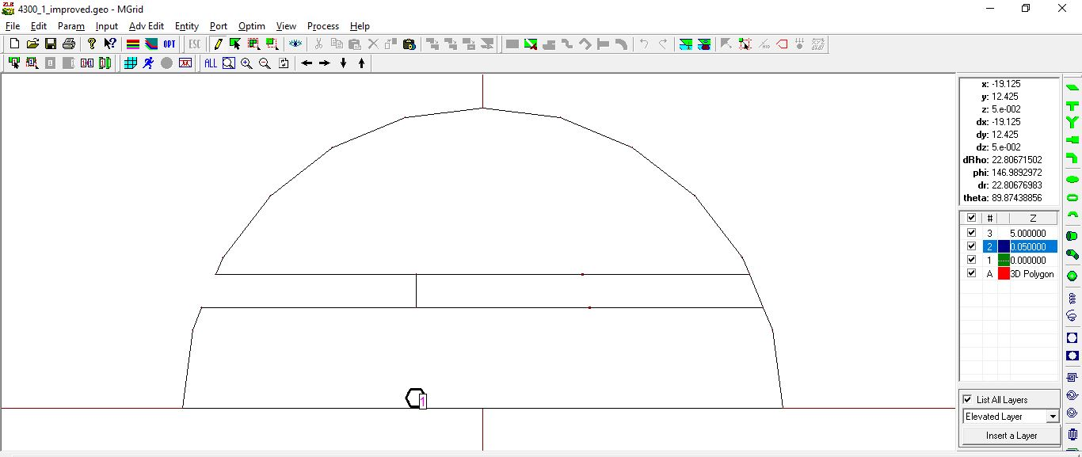

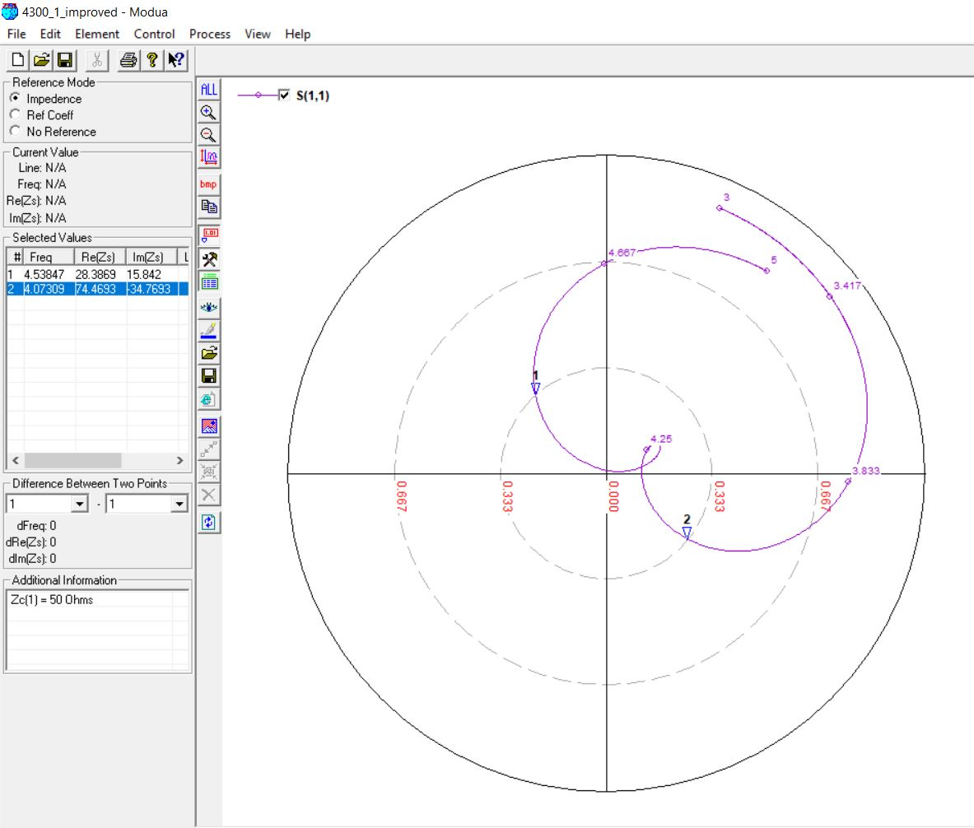

4300 MHz, 5mm (0.07 λ)

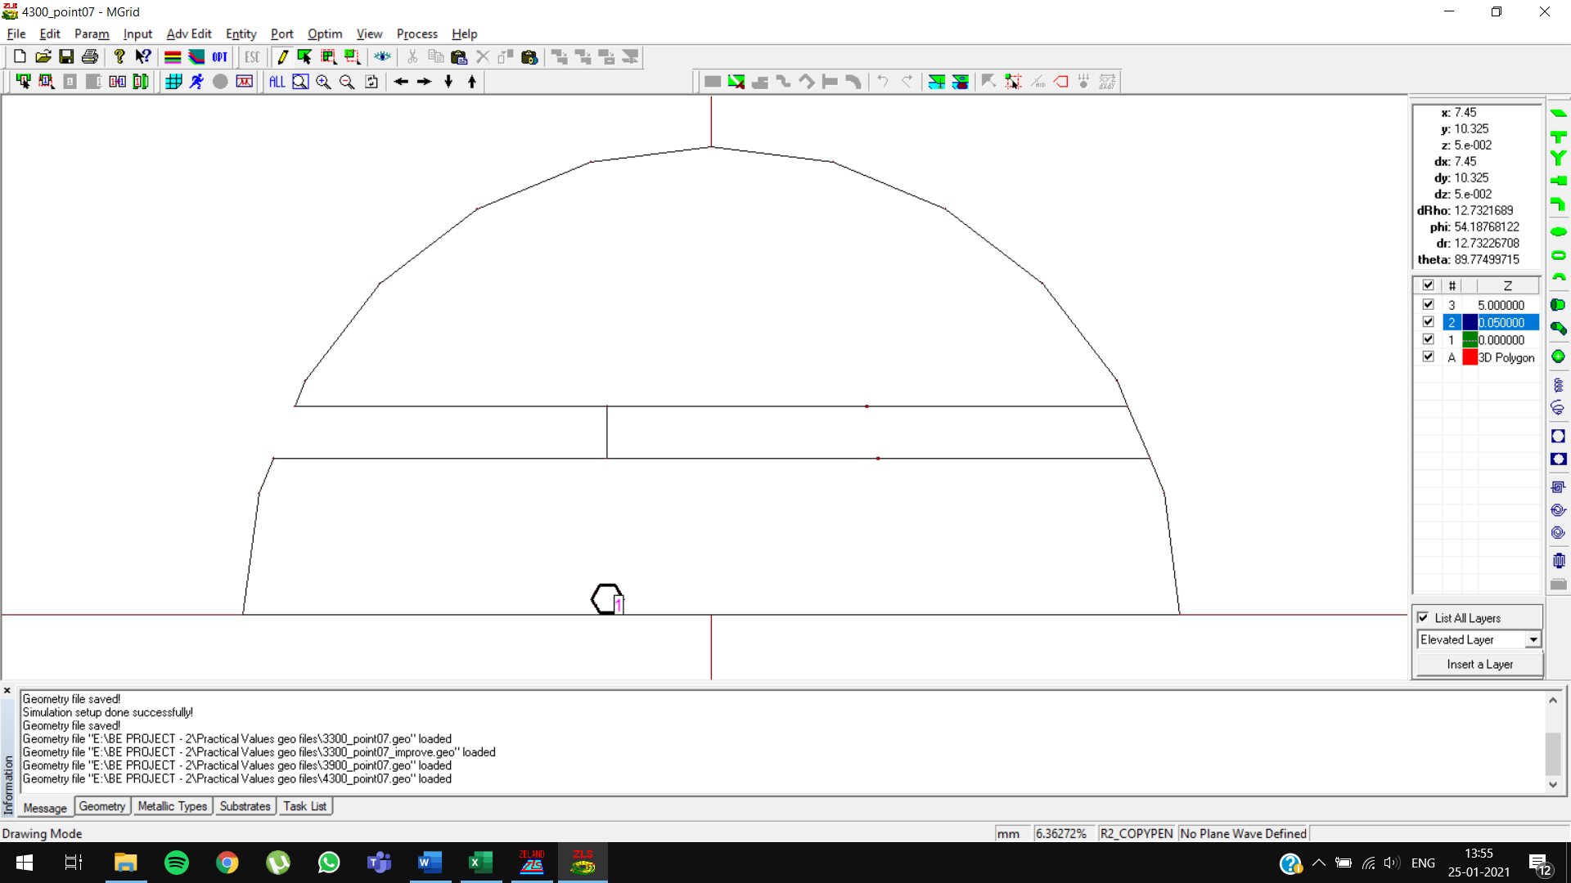

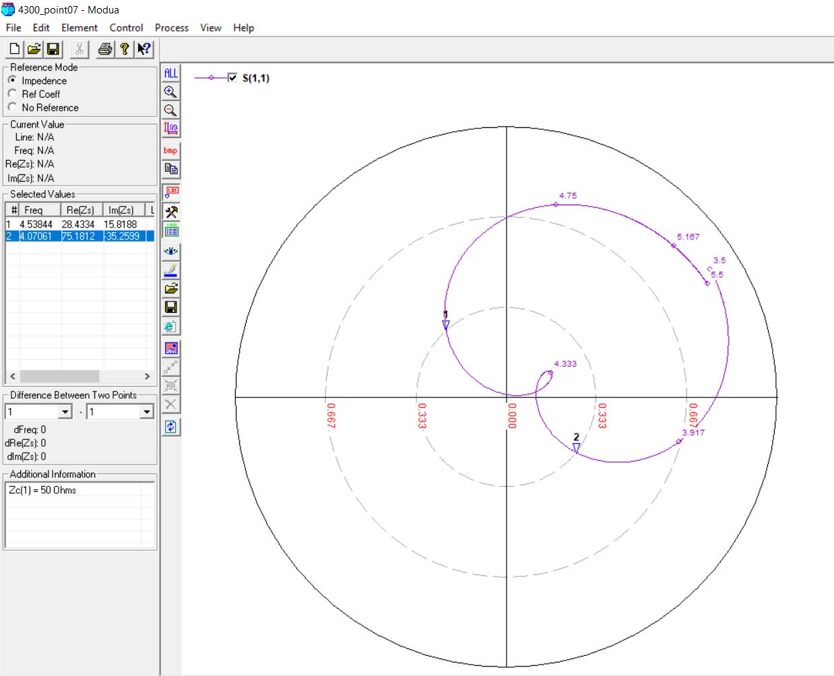

4300 MHz, 5mm (0.08 λ)

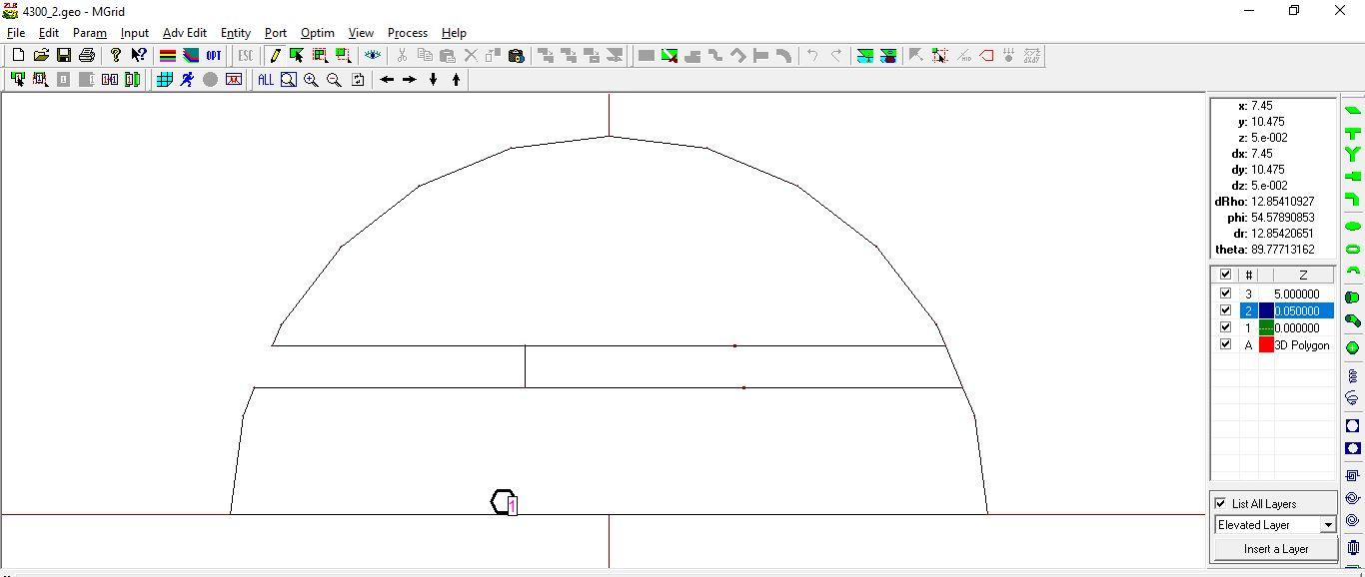



4300 MHz, 5mm (0.08 λ) [OPTIMIZED]

Original Feed Position: -5

Optimized Feed Position: -4

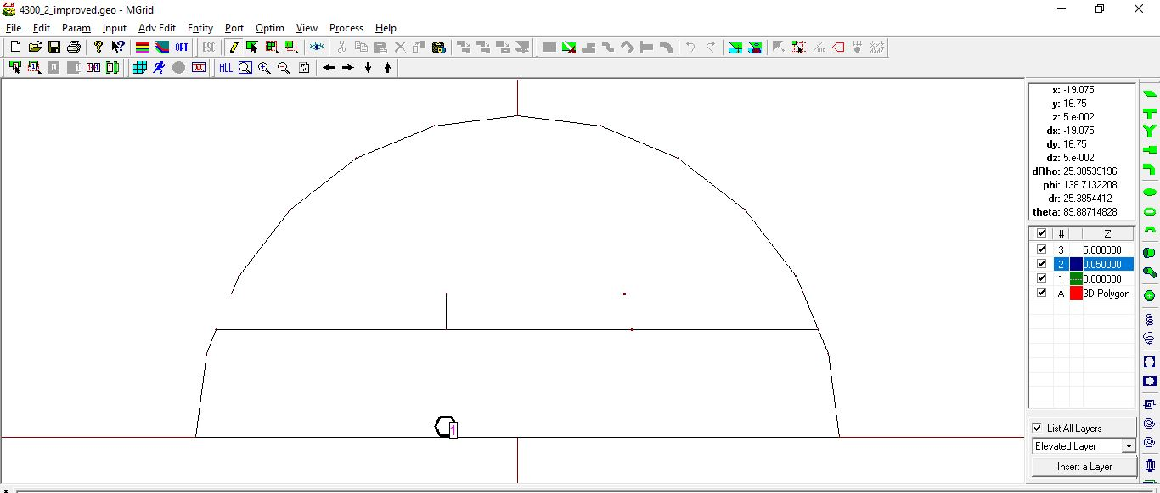



4900 MHz, 4mm (0.06 λ)

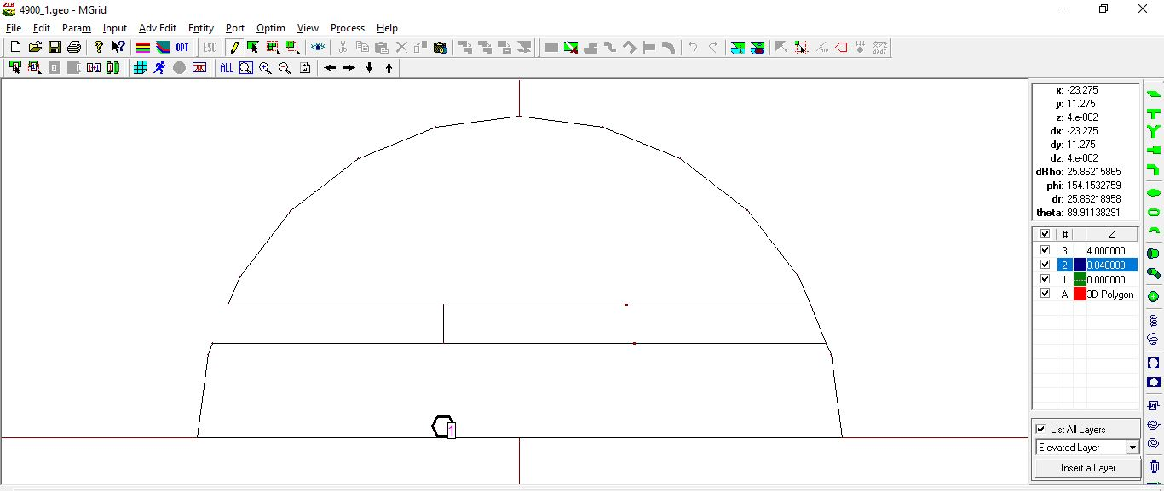

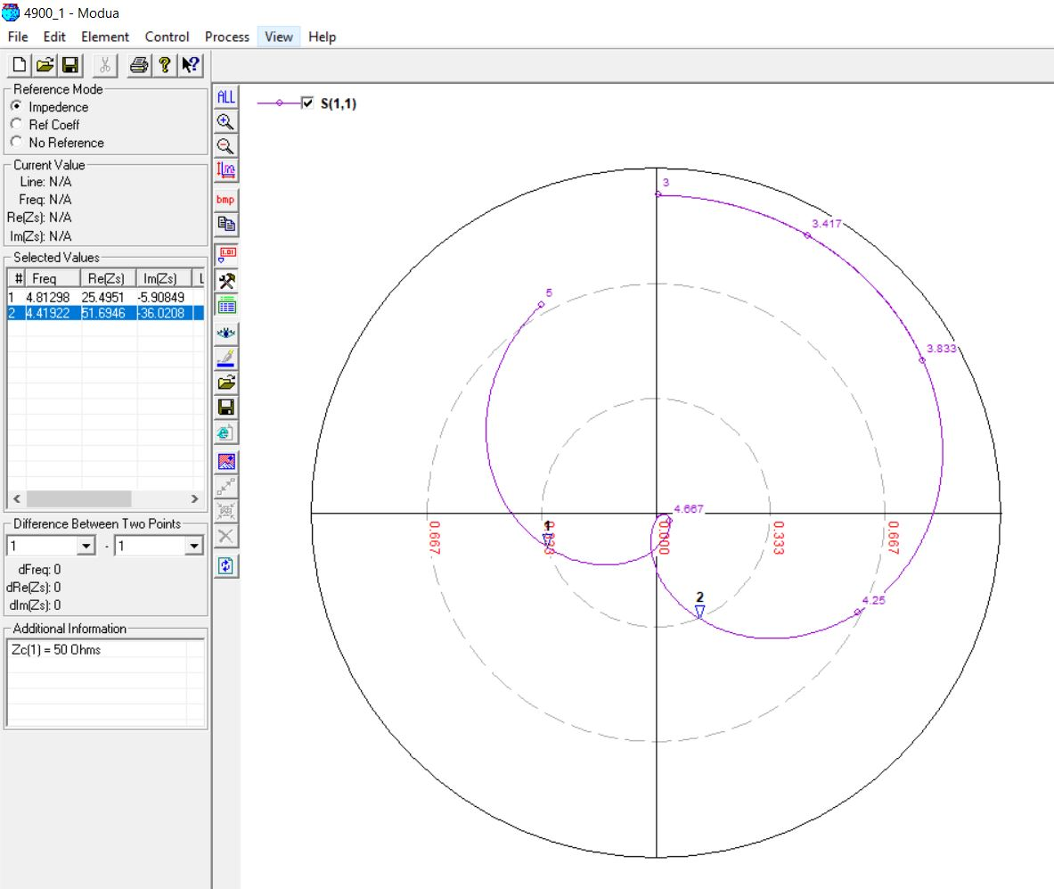

4900 MHz, 5mm (0.07 λ)

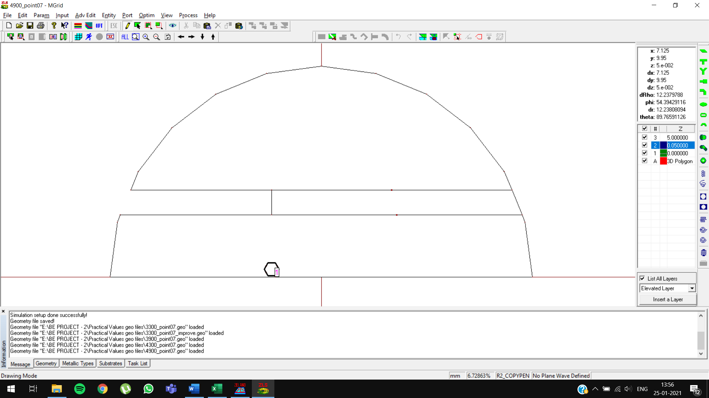

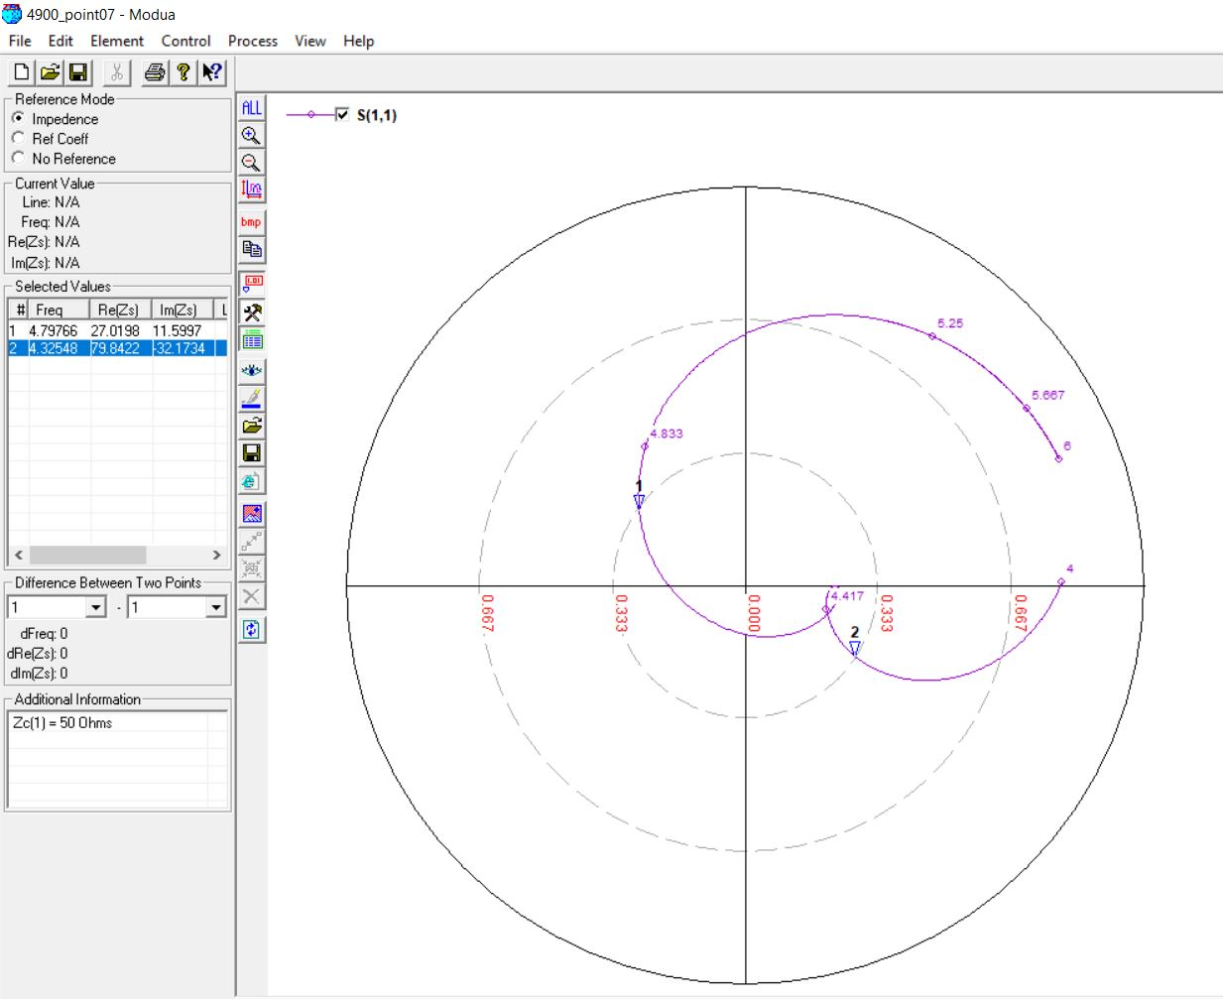

4900 MHz, 5mm (0.08 λ)

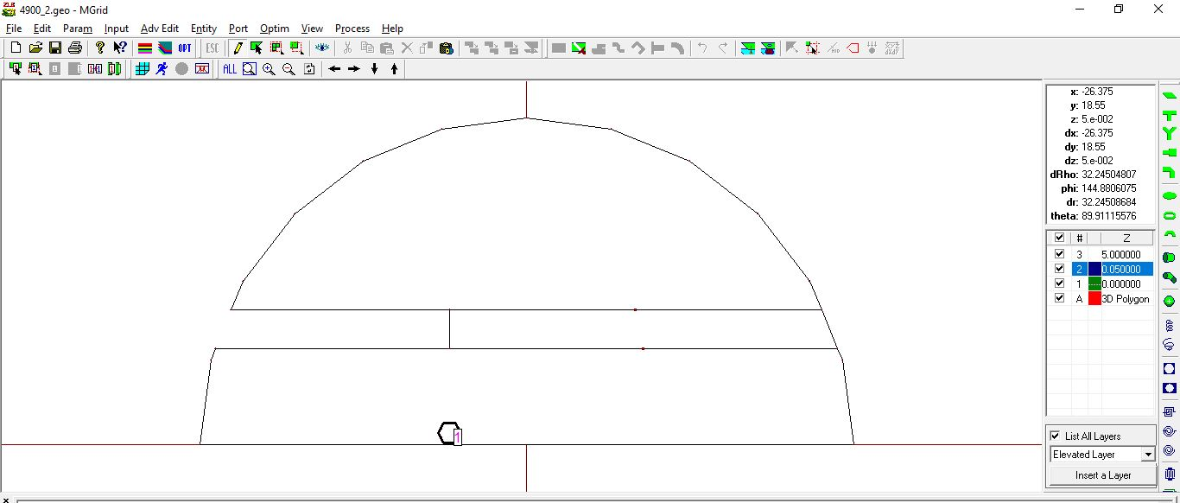

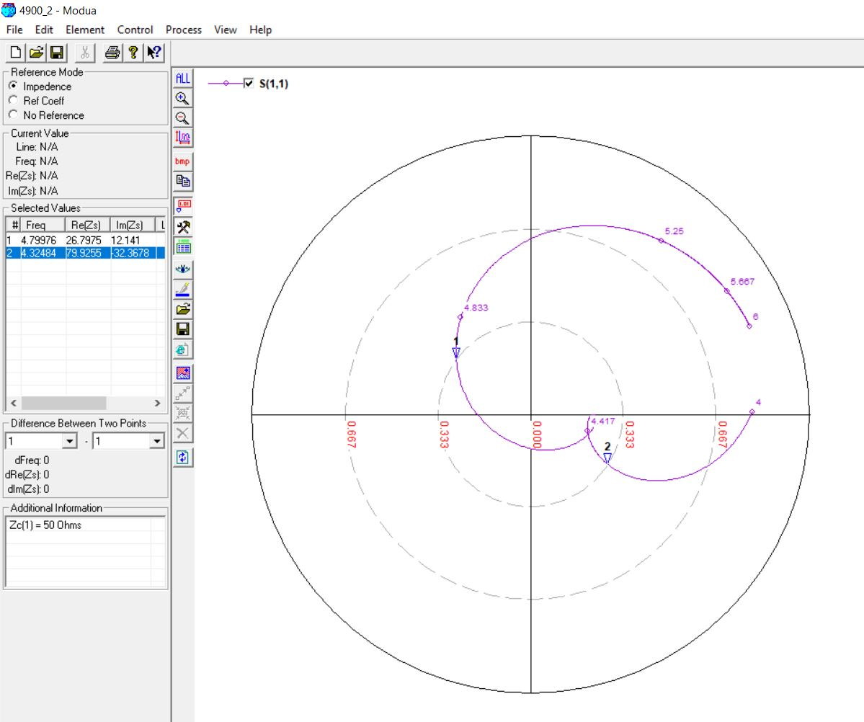

5100 MHz, 4mm (0.06 λ)

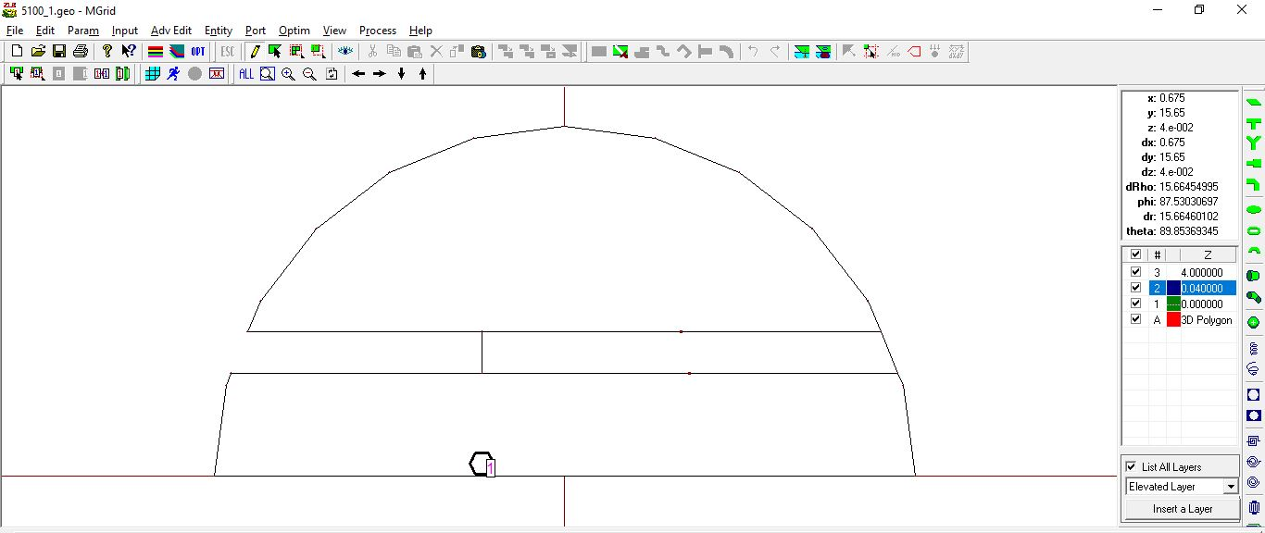



5100 MHz, 5mm (0.07 λ)

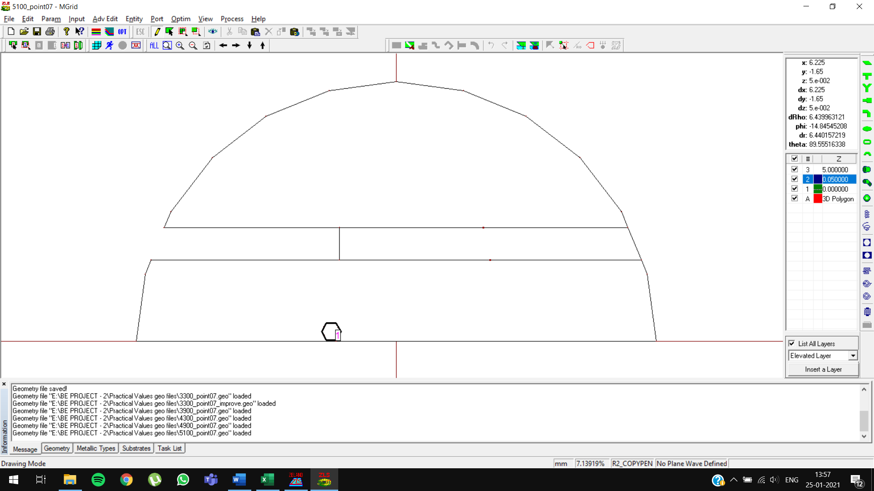

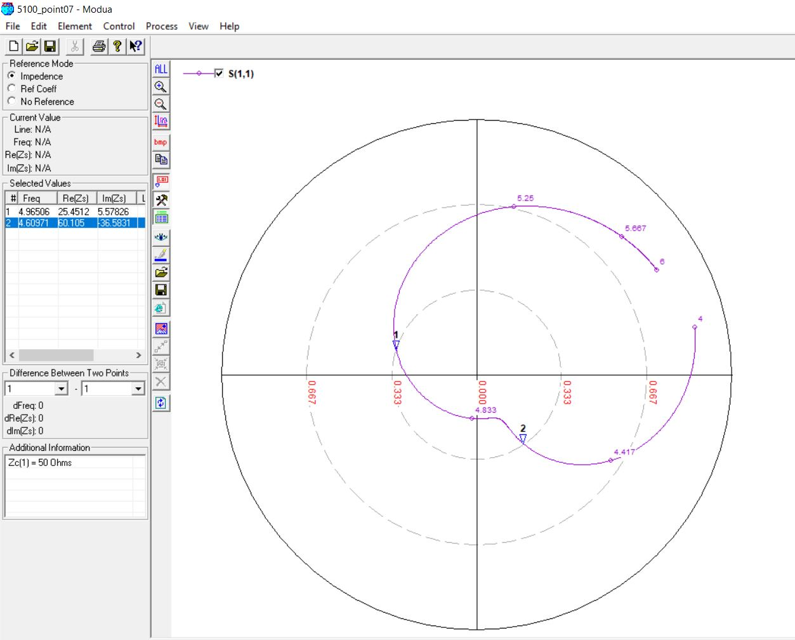

5100 MHz, 5mm (0.07 λ) [OPTIMIZED]

Original Feed Position: -4

Optimized Feed Position: -3

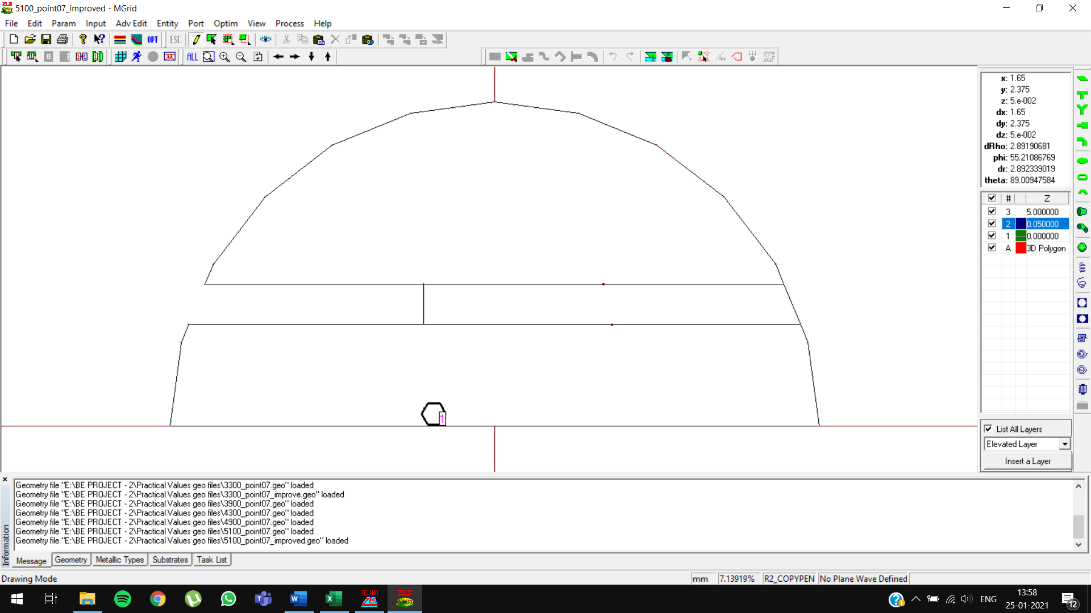

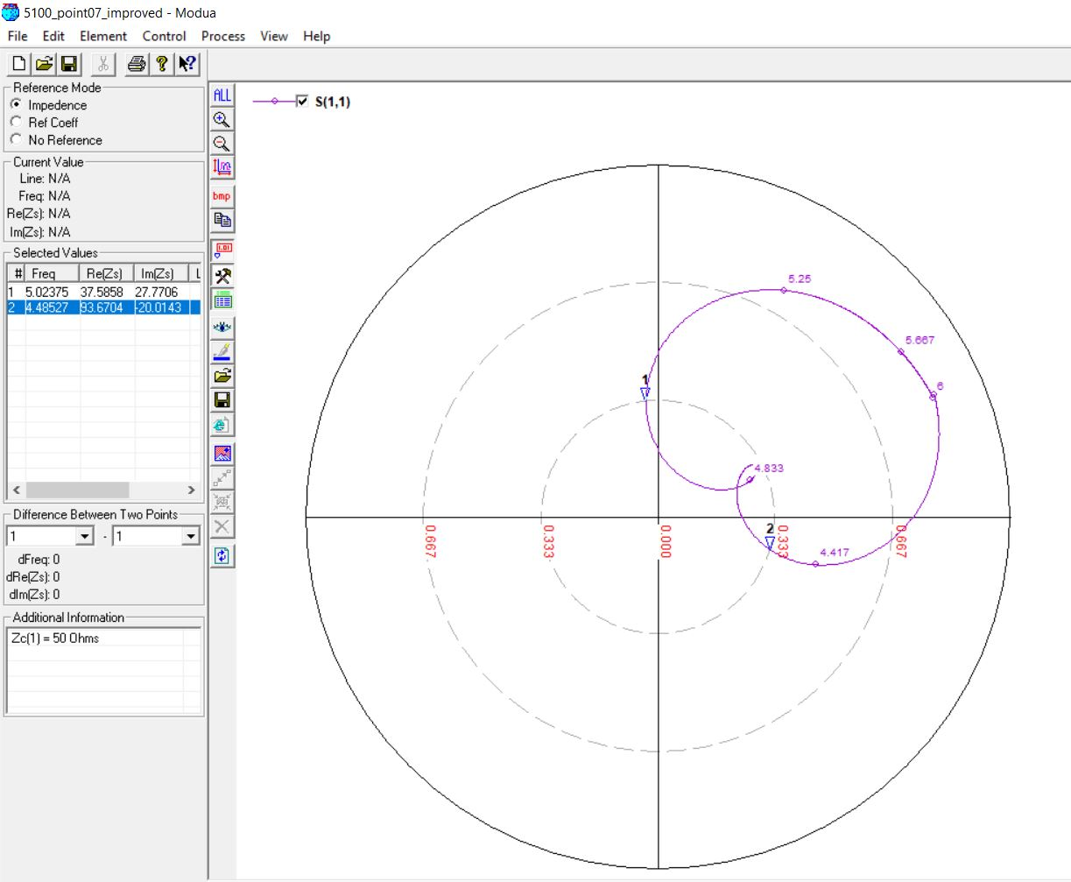

5100 MHz, 5mm (0.08 λ)

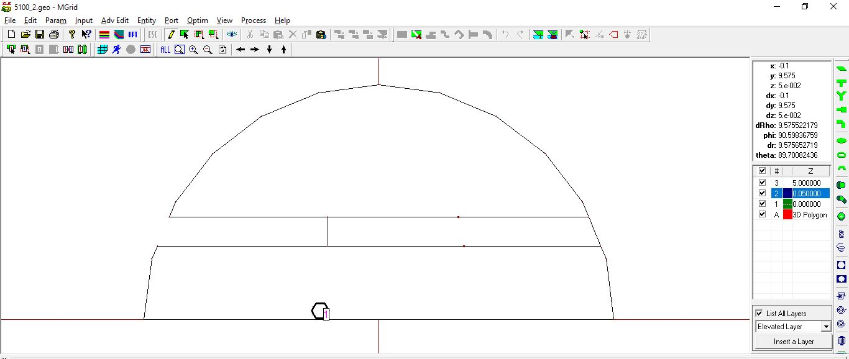

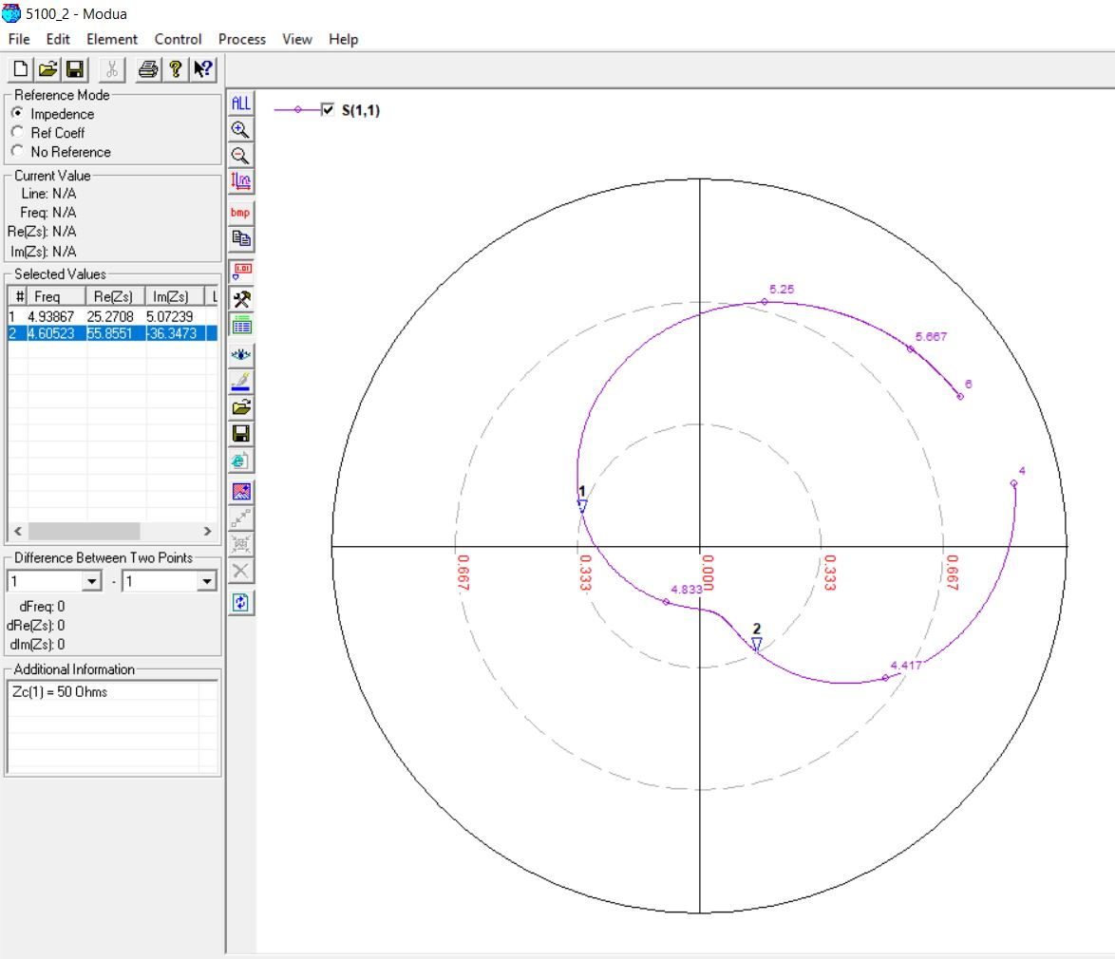

5100 MHz, 5mm (0.08 λ) [OPTIMIZED]

Original Feed Position: -4

Optimized Feed Position: -3

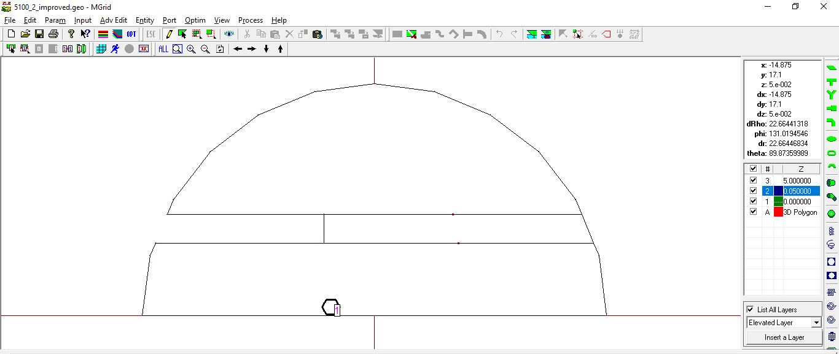

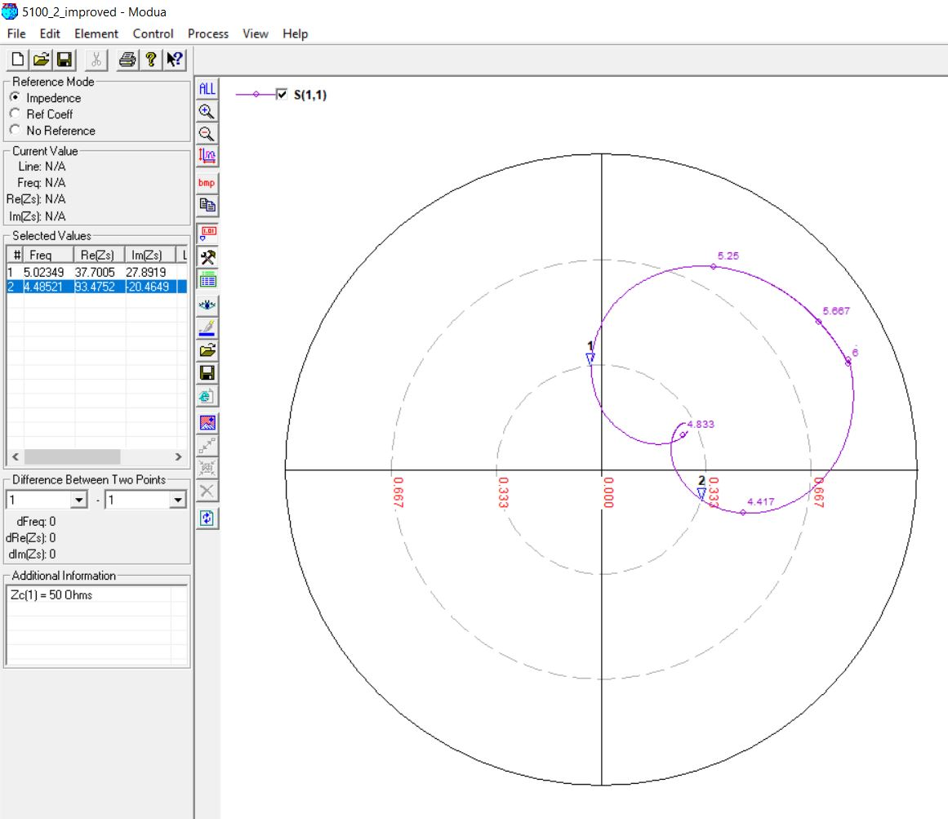

5500 MHz, 4mm (0.06 λ)

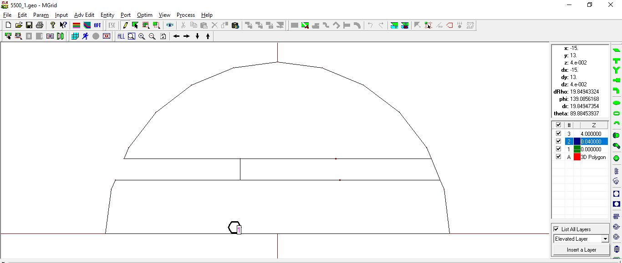

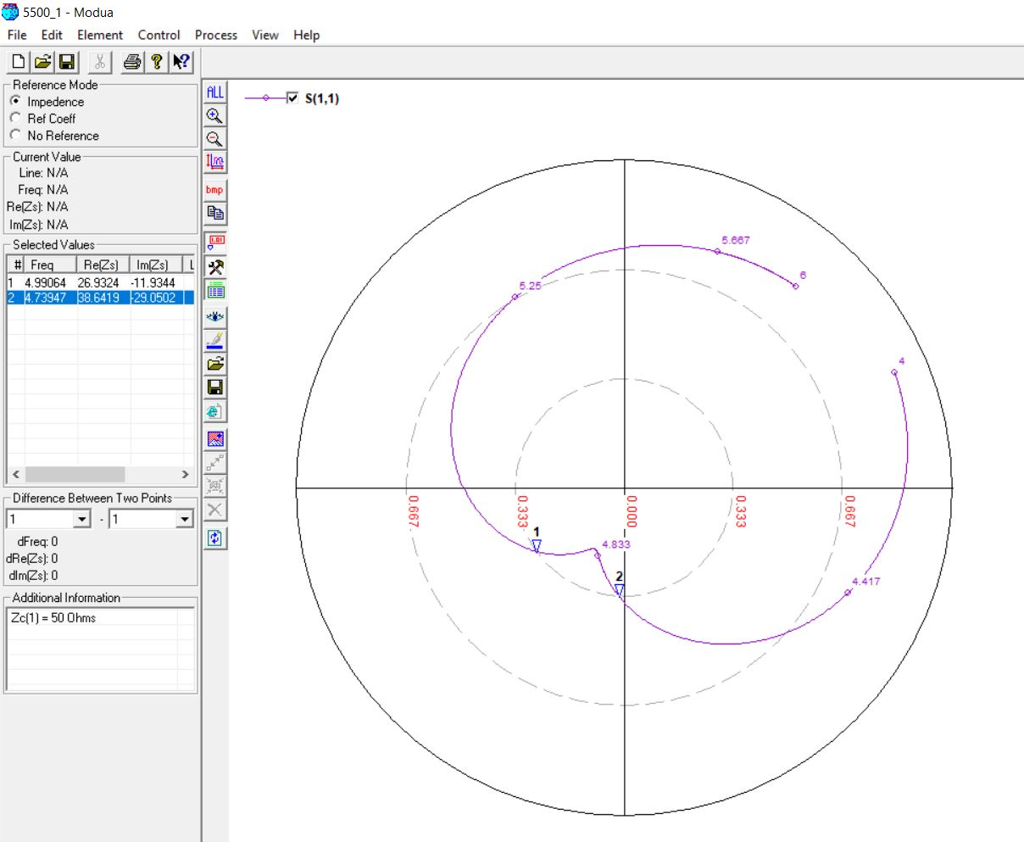

5500 MHz, 4mm (0.06 λ) [OPTIMIZED]

Original Feed Position: -4

Optimized Feed Position: -3

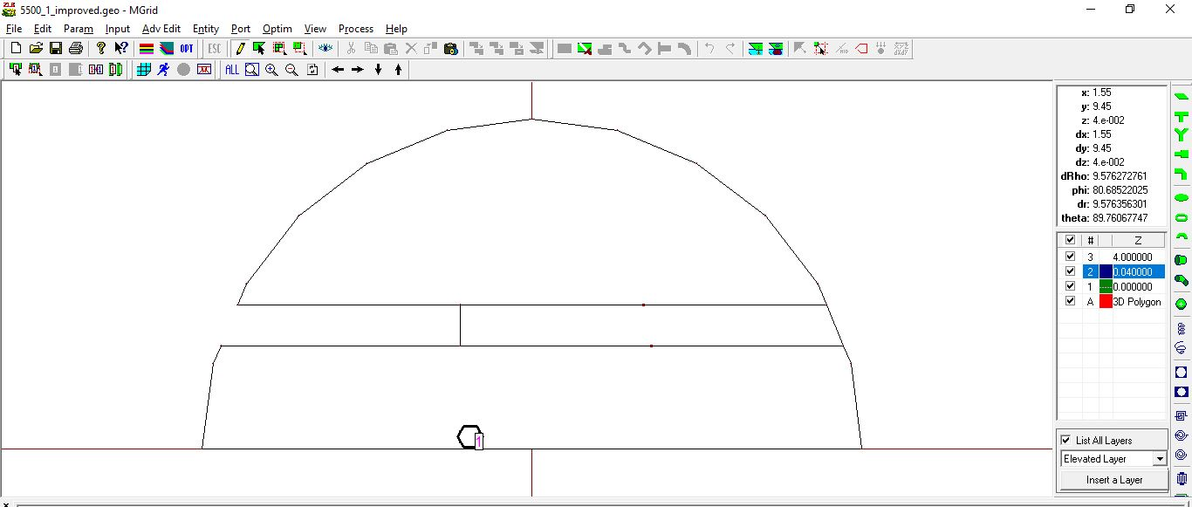

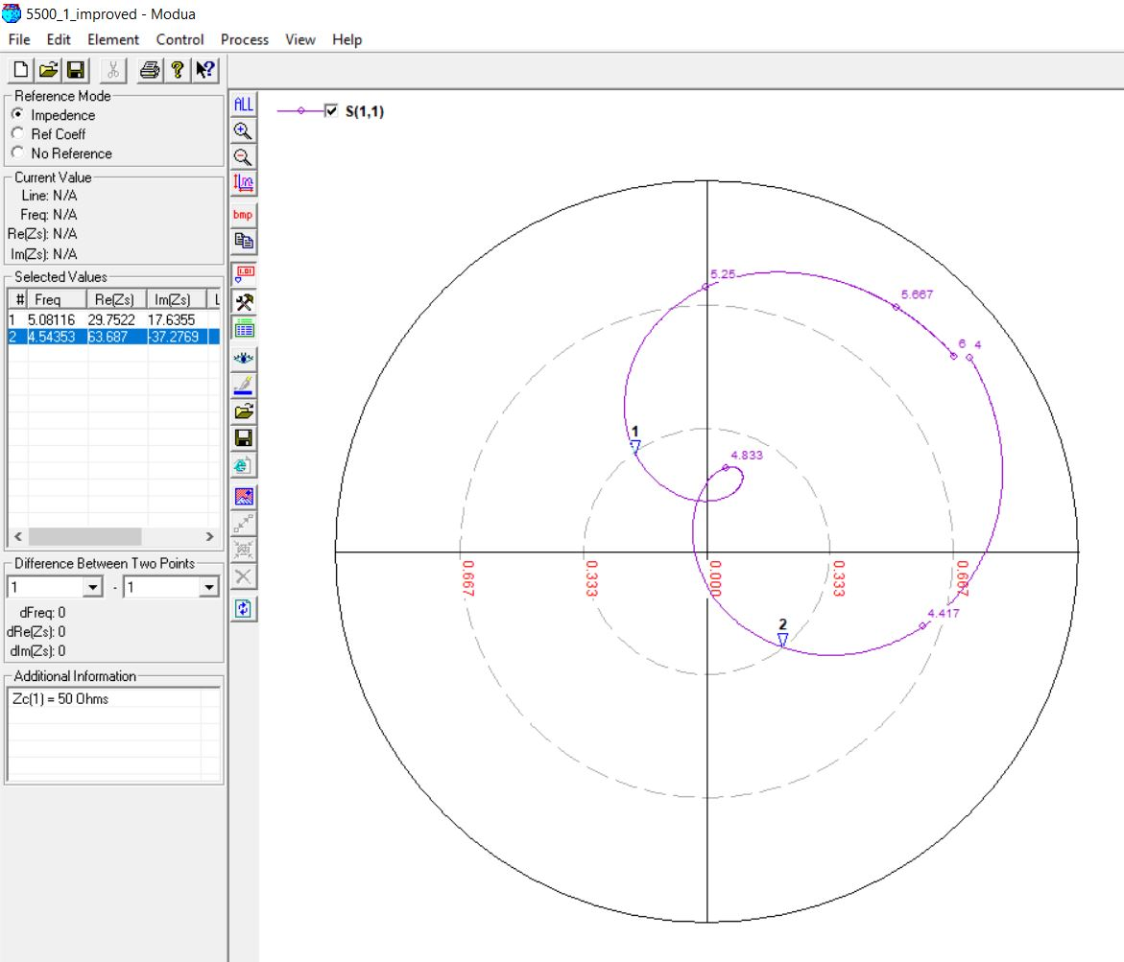

5500 MHz, 4mm (0.07 λ)

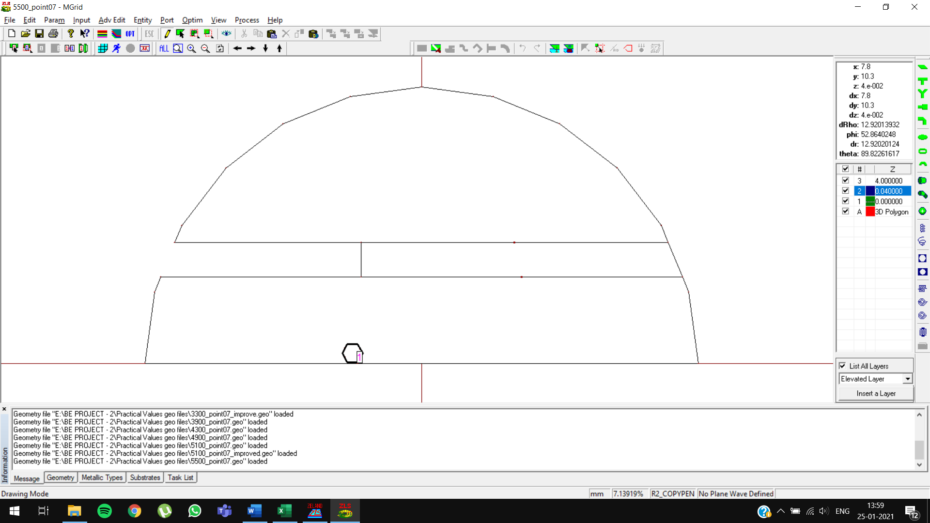

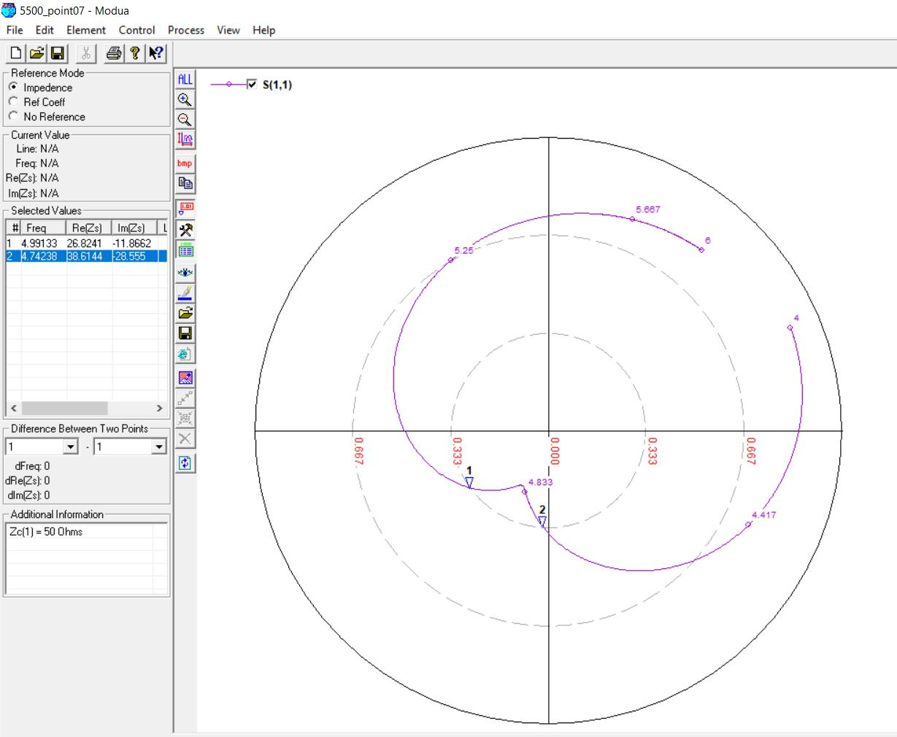

5500 MHz, 4mm (0.07 λ) [OPTIMIZED]

Original Feed Position: -4

Optimized Feed Position: -3

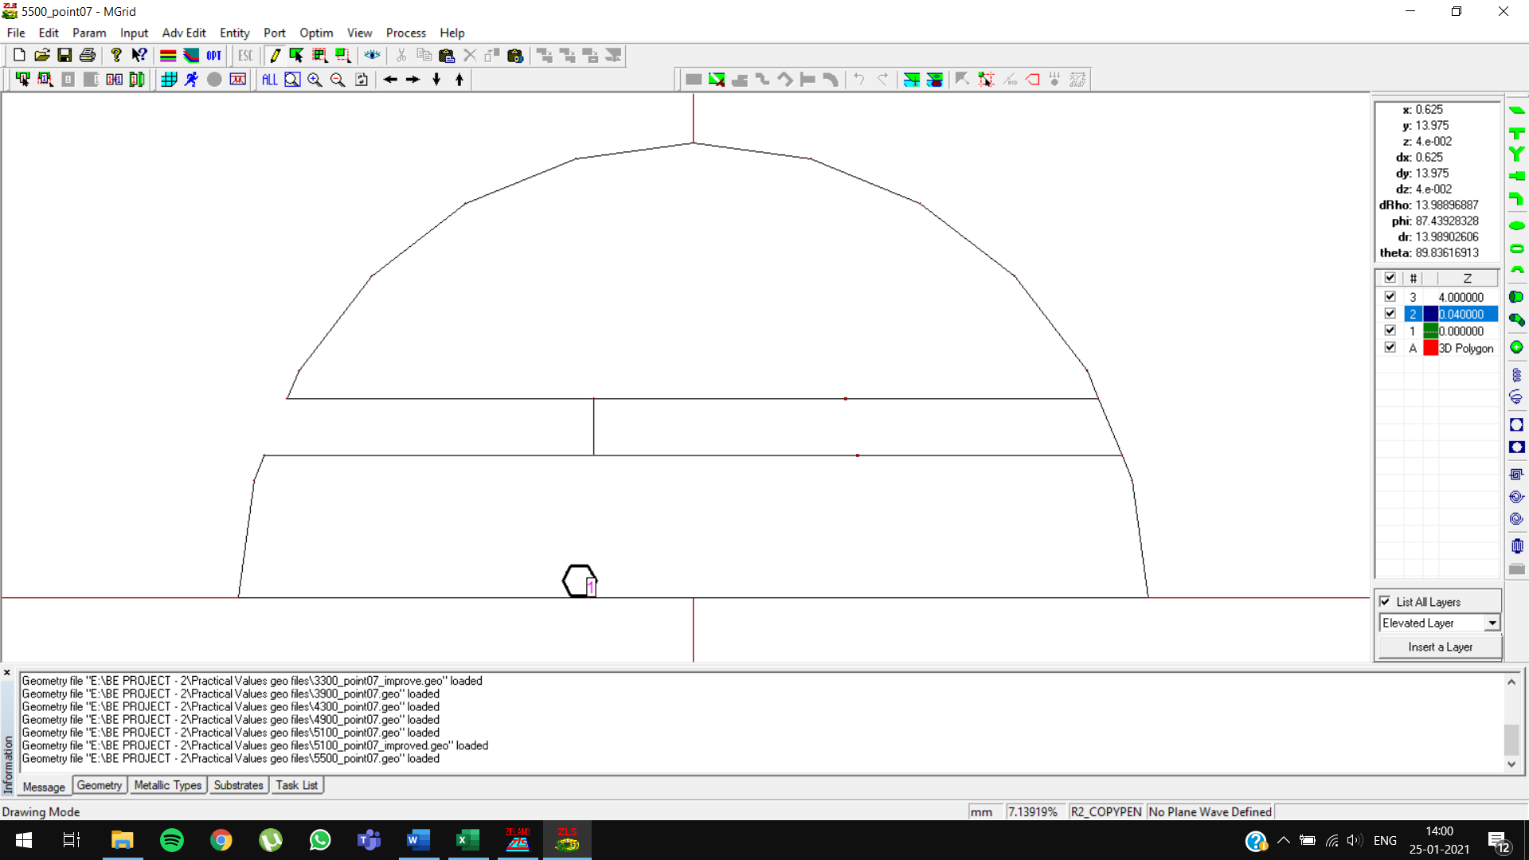

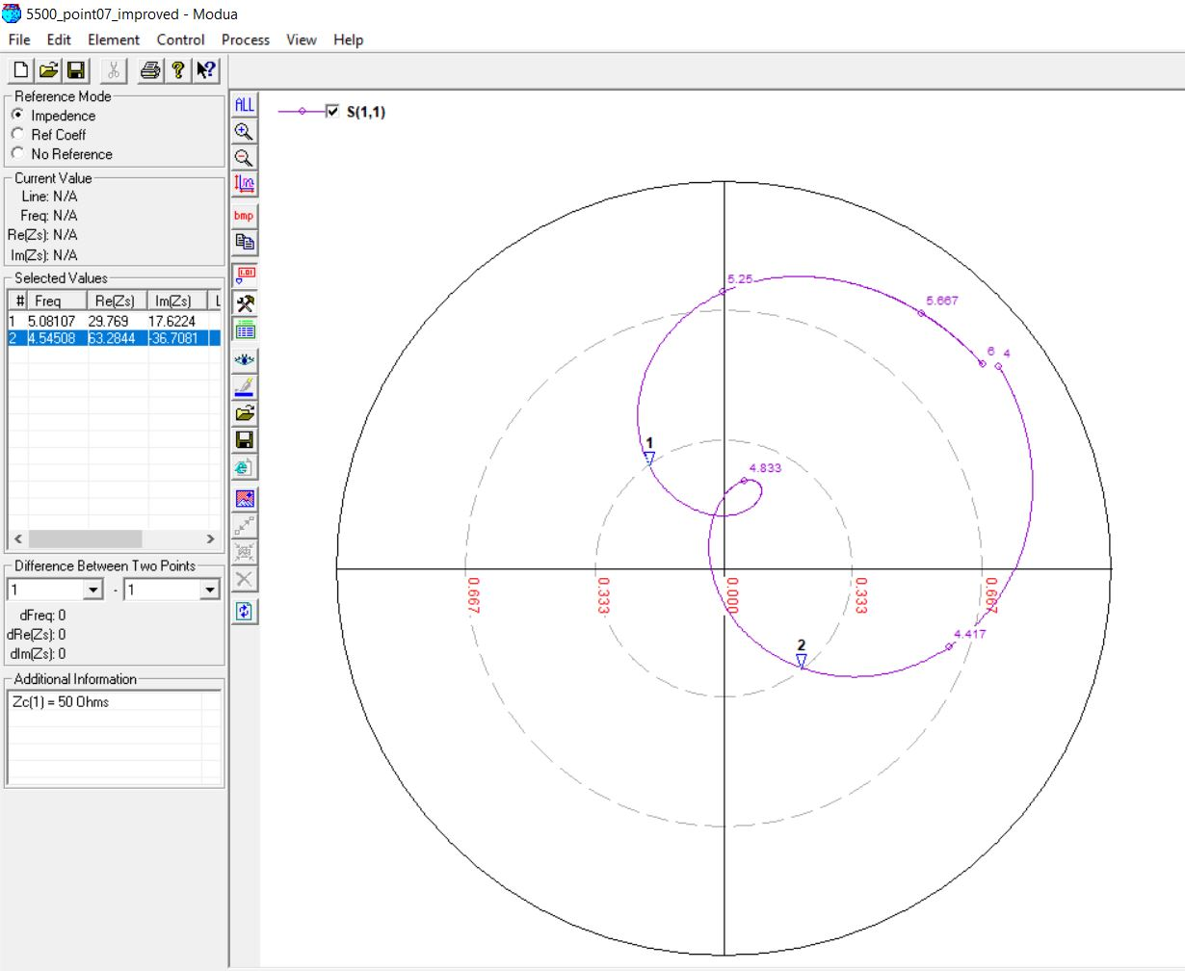

5500 MHz, 5mm (0.08 λ)

